UNEP and IDB GEF PIR Fiscal Year 13
(1 July 2013 to 30 June 2014)

Project Title: | Testing a Prototype Caribbean Regional Fund for Wastewater Management (CReW)

Executing Agency: | UNEP CAR/RCU, Government agencies, waste water utilities in participating countries

Project partners: | Caribbean Environment Health Institute (CEHI) and Caribbean Development Bank (CDB); Caribbean Water and Wastewater Association (CWWA)

Geographical Scope: | Countries of the Wider Caribbean Region (WCR)

Participating Countries: | Antigua and Barbuda, Barbados, Belize, Costa Rica, Jamaica, Guatemala, Guyana, Honduras, Panama, Saint Lucia, Saint Vincent and the Grenadines, Suriname and Trinidad and Tobago

GEF project ID: | 3766 | IMIS number*: | GFL-2324-4A58-2732
Focal Area(s): | International Waters | GEF OP #: | N/A
GEF Strategic Priority/Objective: | IW SO1 & 2 – SP2 | GEF approval date*: | 02 December 2010
IDB and UNEP approval date: | UNEP: 12 January 2012 (delays due to dismantling of UNEP Division of GEF and change of internal procedures thereof)  IADB: 11 May 1011 | Date of first disbursement*: | UNEP: 2 February 2012  IDB: 29 July 2011
Actual start date: | 20 June 2011 | Planned duration: | 48 months
Intended completion date*: | 20 June 2015 (operational closure)  [for UNEP, the administrative closure is scheduled for December 2015 as reflected in the signed ICA with CAR/RCU] | Actual or Expected completion date: | Contingent upon mobilisation of addition PM resources with IADB;  31 December 2015 (operational closure for most components at the exception of perhaps of component 1 )  31 December 2016 (actual administrative project closure)
Project Type: | FSP | GEF Allocation*: | $ 20,000,000
PPG GEF cost*: | $380,000 | PPG co-financing*: | $ 724,500
Expected MSP/FSP Co-financing*: | $251,702,403 | Total Cost*: | $271,702,403
Mid-term review/eval. (planned date): | 31 April 2013 | Terminal Evaluation (planned date): | April 2016
Mid-term review/eval.  (actual date): | January 2014 | No. of revisions*: | Two in total:  One for UNEP to enact the inception workshop and PSC1 recommendations  One to enact PSC2 recommendations
Date of last Steering Committee meeting: | 28-30 January 2014 | Date of last Revision*: | Completed – Dates TBC
Disbursement as of 30 June 2014*: | Total: 10,692,654.24  UNEP: $ 1,311,483.00  IDB:$9,381,171. 24 | Date of financial closure*: | N/A
Actual Completion date*: | N/A | Actual expenditures reported as of 30 June 2014: | Total $6,122,645.46  UNEP: $570,377.00  IDB: $5,552,268.46
Total co-financing realized as of 30 June 2014: | $ USD 600,565,011.00 * | Actual expenditures entered in IMIS as of 30 June 2014*: | UNEP: $ 570,377.00  IDB: $
Leveraged financing: | N/A

* The detailed reports on project expenditure and co-financing are found in Annex I- III.

Project summary | UNEP and IDB jointly requested 20M US$ support from the GEF for the establishment of a Prototype Regional Fund dedicated to wastewater management for the Wider Caribbean. This project (www.gefcrew.org) corresponds to the establishment of this regional initiative which comprises five components:  i) Component 1:  investment and innovative financing for wastewater management;  ii) Component 2: reforms for wastewater management;  iii) Component 3: communications, outreach and information exchange;  iv) Component 4: Monitoring and Evaluation; and  v) Component 5: Project management

Project status FY12  Project status FY13  Project status FY14 | The Project Coordination Group (PCG) is fully staffed and operational. Working relationships have been established with the Inter-agency Coordination Group (IACG) and five Executing Agencies (EAs).  With regards to Component 1, agreements have been signed with three of the four pilot countries (Guyana, Belize and Jamaica) to facilitate disbursements of funds to enable the establishment of the financing mechanisms; and in the case of the fourth pilot, in Trinidad and Tobago, a draft agreement has been developed and is under negotiation. In the meantime, operational manuals have been finalised and Pilot Management Units have been established in Belize, Guyana and Jamaica. In terms of the first generation projects, tendering of the design and works is progressing for Belize, this involves one new facility in Placencia, and for Jamaica 14 existing plants are slated for upgrade. Guyana has developed an outreach programme to help identify its first generation projects targeting the private sector and public/private partnerships. Trinidad and Tobago have identified the upgrade of the Scarborough Waste Water Treatment Plant in Tobago as its first generation project.  In terms of Components 2 and 3 the baseline study is underway. Additionally, direct contact has been made with several of the countries to determine/clarify their needs with respect to wastewater reforms in an effort to determine the best approach to that intervention. A number of communication products have been launched; these include the project website, e-bulletins and the quarterly newsletter along with communication guidelines for the five executing agencies. Capacity building activities are underway with two workshops planned; one on Wastewater Management Technology and the other on Revolving Fund Management. Both these workshops are demand driven, in response to the request of the participating countries. The CReW has also been represented at a number of regional meetings chief among which was the Scientific, Technical Advisory Committee (STAC) on Land Based Sources (LBS) Protocol at which the project’s contribution to pollution reduction issues was outlined.  The first year has been challenging and while there has been some slippage, the project remains on track for completion in 2015.  Component 1 - Since the last reporting period, the Government of Trinidad and Tobago (GOTT) became the final of the four demonstration countries to sign an agreement with the Bank, which will enable the establishment of the pilot financing mechanism. The GOTT still have to fulfil the conditions prior to facilitate the disbursement of the US$ 2 M needed to capitalise the revolving fund. In the case of the other three pilot countries who all signed agreements in the preceding year; Guyana and Belize have established Revolving Funds Boards for management of the facility, however, funds are yet to be disbursed. The reasons for the delay capitalising the funds vary in for each of the two countries. Guyana’s revolving fund is based on a model of public private partnerships and the main clients for the Fund were expected to come from the private sector. However, while several inquiries have been made the PEA/PMU has yet to identify a first generation project. To a large degree this is due to the absence of the necessary drivers chief among these are strong environmental regulations. The Belizean Government has been in a series of negotiation with international lenders regarding its national debt and as a result opted to defer requesting the disbursement of the US $ 5M until the debt negotiations had been finalised. The Government of Belize have signalled that they will be requesting disbursement in October 2013. With regard to first generation project, the tendering of the design works in Belize was significant stalled because of an impasse with the Water Boards which delayed the transfer of assets to the Belize Water Services (BWSL). The uncertainty which resulted led to a delay in the tendering of the design, which means that the Placencia Project will not require loan funds before January 2016. In the meantime, a new alternate project has been identified in Belmopan involving the upgrade of the treatment works and extension of coverage. This project will be the first to be funded by the BWRF after which funding will be available and used to fund the Placencia project as originally intended. This means that Belize will benefit by funding more than one project. In the case of Jamaica, a commercial bank has been selected and a commitment letter signed between the bank and the National Water Commission (NWC) to the tune of US$ 12 M to fund the rehabilitation of a total of 13 wastewater treatment plants. As a result, the Bank transferred the GEF CREW US $3 M to a reserve account to be used as collateral. The remainder of the collateral will be provided by the NWC K-Factor fund. The NWC is currently negotiating the contract for the loan. For Jamaica 13 existing plants have been identified. For 2 of the 13 the tendering process has been completed and the other 11 are currently inviting tenders.  Component 2 During the year the baseline study for the English speaking countries was completed. Based on those findings UNEP CAR/RCU began a number of bilateral discussions with countries in order to shape their national capacity building programmes. To date 4 agreements have been finalised and 3 others are in various stages of development. A number of regional workshops have been held these include two wastewater management workshops for English and Spanish Speaking countries held in the Bahamas and Costa Rica in October and November 2012 respectively. These workshops we executed with the support of the Water Center in Monterrey, Mexico. The Water Center is supported by the IDB and there are many areas of their work which are of importance to the project. The Water Center has tremendous capacity and experience in online training and given the need to continue to build capacity at the individual and institutional levels the project has developed an aide memoir with the Center to collaborate in the delivery of on line courses targeting wastewater professionals working in utilities and environmental sector. The first of the courses will be rolled out to Spanish Speaking Countries in November 2013. The project is also working to link the Center with two universities in the English Speaking Caribbean – UTECH and UWI to have exchanges in training and research in order to strengthen the capacity within the sector. These activities are important to the legacy of the CReW as it is intended that the current collaboration will continue long after the project is concluded. In addition, the project supported a regional workshop in the management of Revolving Funds; in this case the USEPA provided valuable resource personnel for the workshop. Arguably, the most impactful workshop was the one on facilitation hosted in Jamaica at which all the participating countries were present. The objectives of the workshop were to provide professionals with different tools to be used in building consensus and making decisions. The decision to host this workshop was strategic given the highly political nature of the sector and the diversity and complexity of the issues as a result of which decision making is often paralysed and the sector suffers. The workshop is intended to provide the technocrats with the facilitation tools to remove the barriers to decision making.  Component 3 – A total of 4 newsletters were published (www. gefcrew.org) during the period. The project has also launched a Facebook site intended to widen the outreach. Contracts have been signed to produce a number of videos and the project is working on its visualisation tool. As it relates to replication two contracts have been signed to provide studies of organisation readiness and to capture the experiences to date as part of developing sufficient information to inform the replication strategy.  The activities implemented in the first 6 months of 2014 have started incorporating the recommendations of the MTR and decisions of the PSC meeting.  Component 1  PROJECT OVERALL  - The PSC took place in January 2014, the MTE was presented, also during the committee; a facilitation workshop was carried out to draft the first thoughts/ideas of what could be the second phase of the project.  - The PSC approved a one to one and a half year extension of the project, without incurring in any further expense to GEF. Still to determine the sources of the amount needed for this extension, estimated in US$ 547,674 for one year extension and US$ 806,911 for a one and a half years.  PCG  Because of personal reasons, the Project Coordinator resigned from the position in May 2014. In the interim the Technical Specialist is working as acting PC. The IDB plans to finalize the procurement of a new PC by July-August 2014.  PILOT PROJECTS  Since the last reporting period, the status of the project by the pilot countries is the following.  BELIZE:  Disbursement:  Financing Mechanism funded: The fund was capitalized with US$ 5M by October 2013  First Generation Project Design (cost covered by IDB): For the reporting period there has been no disbursement. The reasons for this are detailed in the pilot project description below.  Pilot project:  Placencia:  The design of the project is ongoing pending decision by the government on the final location of the wastewater treatment plant. Significant potential social and or political impacts and the needs for extensive local community acceptance have caused some delays in the final decision making process hence making site agreement on the final site difficult. As per the planning provided by the PMU, the expected date for the finalization of the design is now April 2015. Disbursements are not expected until August 2015 with the end of the construction scheduled for August 2017.  Belmopan:  The design of the collection system and the upgrade of Belmopan Wastewater Treatment Plan have been finalized.  The procurement process will start in September 2014 and should be completed by December 2014.  The work shall thereafter commence in January 2015 with completion scheduled for June 2015.  The total cost is estimated by the Belize Water Services (BWS) is US$ 1.5 million  Other activities (funded by the project development support budget allocation assigned to each country):  Fred Gould, International consultant was hired to act as Design Supervisor for the Placencia and Belmopan wastewater Projects, and to review and comment upon the Nutrient Fate Study and upon the Market Effluent Study.  GUYANA:  Guyana’s revolving fund is based on a model of public private partnerships and the main clients for the Fund were expected to come mostly from the private sector but now will also come from NGO, local community, even governments, etc.  Disbursement:  Financing Mechanism funded: No disbursement has been done to date due to the fact that a pilot project has yet to be identified. The amount allocated for this pilot project is US$ 2 M.  First Generation Project Design:  Pilot project:  Several proposals were tabled but the PEA/PMU has yet to identify a first generation project. The flagship project Demorara Distillery Ltd has officially informed the Guyana Waste Water Revolving Fund (GWRF) of their non-intention to pursue an investment in a wastewater treatment plant at this time. The PMU continues to engage with the other previous Projects such as Splashmins, Puran Bros Incorporated, Country Wide Disposal Services and Caribbean Containers Incorporated. Further discussion have been initiated with Windsor Estates, a new 65-acre housing establishment, the Guyana Pegasus Hotel and the Gold and Diamond Miners Association as to get their interest in becoming a pilot.  Other activities (funded by the project development support budget allocation assigned to each country):  Development of the Policy and Operational Framework of the GWRF, originally executed by Mr Martin Baker, has been terminated, and a replacement Consultant is in progress.  Targeted Promotional Campaign for First Generation Projects of the GWRF, executed by Shonnet Moore has had a disbursement of 35% of the Consultancy Fee.  JAMAICA:  The current IMF agreement with the Government of Jamaica and the financial rules applied to Government agencies have impacted the ability of our project to move in a timely manner. During the reporting period the commitment letter was signed between the National Commercial Bank (NCB) and the National Water Commission (NWC). The signature of the Loan agreement for an amount of US$ 12 M has however not yet taken place. Arrangements are being made by NWC and the NCB the agreement to be signed no later than July 2014. There cannot be disbursements to the future Contractor in charge of the works till this signature is secured.  Disbursement:  Financing Mechanism funded: The fund was capitalized with US$ 3M during the previous PIR reporting period in February 2013 with funds deposited in the National Commercial Bank account.  First Generation Project Design:  Pilot project:  During the reporting period much emphasis was spent administering and/or evaluating several significant procurement exercises which were issued by the PMU. These included the following requests for proposals (RFPs):  - Boscobel Elletson Flats Wastewater Treatment Plant Replacement Project, Award of Contract to VINCI Construction in the sum of US$4,131,683.01. The Contract is expected to be signed in the next reporting 3rd quarter of this year (July – September 2014).  - Design and Build of 3 Wastewater Conveyance Systems. 3 bid proposals were received. These proposals have been evaluated and the Evaluation Report submitted to the IDB and endorsed by the Audit & Finance Committee of the NWC Board on June 16, 2014.  - Design and Build of 3 Wastewater Treatment Plants (Pond Systems). Only one responsive bid was received. The Evaluation Report has been finalized since June 27, 2014. Arrangements are being made to forward Evaluation Report to the IDB in July 2014 for their no objection following which presentation to the requisite committees (internal and external) for endorsement of Contract.  - Design and Build of 5 Wastewater Treatment Plants (Mechanical Systems). 5 Bids were returned and are currently still being evaluated and the technical evaluation report is to be submitted to the IDB for their non-objection to proceed with the opening of the financial proposal in July 2014.  - Provision of Engineering Consultancy and Works Supervision Services for Rehabilitation of Thirteen (13) Wastewater Treatment Plants. 3 Bid proposals were received. The Technical Evaluation of the proposals was completed and forwarded to the IDB in the last week in June 2014 to request permission to proceed to the next stage of the evaluation process (opening of the financial bid) before the final evaluation report is completed.  Other activities (funded by the project development support):  - The environmental consultancy to assist the PMU with technical matters has been awarded to Dr. Nilza Smith. She has submitted her preliminary draft report in May 30, 2014.  - Auditing Services for the Project funds. Draft Contract with KPMG (selected in previous period) was issued to IDB for review and approval to proceed with Contract on June 2, 2014. Expected signature with KPMG to happen during the first week in July 2014  - Wastewater Training Programme for Operators was organised in partnership with UnivTECH in Jamaica. Draft Contract has been forwarded to the IDB procurement specialist for review and accepted on June 12, 2014. Training Programme was however launched on June 3 2014. Seven (7) NWC personnel are currently participating in the course.  TT:  Preliminary activities were undertaken by Waste And Sewage Authority (WASA) and discussions are ongoing to ensure effective implementation once planning process is completed. However to-date, the country has not met all of the conditions to enable the disbursement of the US$ 2 M needed to capitalise the revolving fund. An extension has been granted till the 24 September 2014.  Disbursement:  Financing Mechanism funded: N/A  First Generation Project Design: N/A  Pilot Project: N/A.  Other activities (funded by the project development support): N/A  The following highlights the major progress under the two Components executed by UNEP CAR/RCU.  Component 2  Terms of Reference (TORs) were developed for the redesign and enhancement of the current GEF CReW Project website and visualization tool (which will be embedded in the website). Consultancy began in early-June.  Drafts of framework template and toolkit for developing/updating wastewater policies and developing/updating wastewater management plans received from external consultant. They will be made available by end of July 2014.  Discussions initiated with Antigua and Barbuda to provide national financial capacity building to the national utility. Due to poor feedback, other activities are now being considered, the pilot testing of reuse of wastewater as a resource in collaboration with the FAO and to be implemented pilot activities in in Saint Vincent and the Grenadines and Antigua and Barbuda.  The consultant’s report: “Review of the Assess to, Availability of, and Organizational Readiness for Uptake of Funding for the Wastewater Sector in Selected Participating Countries” was revised and finalized following presentation at the Third Project Steering Committee Meeting and comments from participating countries. Available now through the Web site.  Technical advisory group of country focal points established to support the development of an implementation plan for a monitoring, evaluation and reporting system for wastewater management including the design for a wastewater management M&E database. Works will continue next quarter.  UNEP CAR/RCU began a number of bilateral discussions with countries in order to shape their national capacity building programmes called Small Scale Funding Agreements.  SSFAs  SSFA English Speaking countries: Ongoing in Antigua and Barbuda, Belize, Saint Lucia, Barbados and Guyana. In Jamaica will support National Capacity Building and Policy, Institutional and Legal reforms for Wastewater management has been delayed due to lack of fiscal space to receive funds by the Ministry. Draft SSFA of Suriname was finalized but awaiting input of banking information and additional budget details before signature. Discussions continued with officials in St. Vincent on possible areas of support to be developed by end of July 2014.  SSFA with Suriname NGO for rural communication strategy on sanitation (Under discussion with Government)  SSFA Spanish Speaking countries:  Baseline Assessments for Belize, Jamaica, Costa Rica, Guatemala, Honduras and Panama were edited formatted and was posted on GEF CReW website. Final versions were also provided the GEF PCG.  Final report for LBS Compliance in Spanish-speaking countries was received from RAC/CIMAB and posted in April. This report will form the basis for developing Small Scale Funding Agreements (SSFAs) with Panama, Honduras, Costa Rica and Guatemala which will be coordinated by RAC/CIMAB in Cuba. Discussions involving RAC CIMAB, CReW Focal Points from the four countries, Acting Project Coordinating of the GEF CReW Project and UNEP CAR/RCU are ongoing to define in details the areas of support for each country. Signature of the SSFAs which each of the four countries expected no later than August 2014.  SSFA with RAC CIMAB to provide technical support and oversight on capacity building to CReW Spanish Speaking Countries including hosting of training workshop on lab analysis (July)  SSFA Others:  SSFA Water Center: to provide training for Spanish-speaking CReW countries for online courses in various aspects of wastewater management, respectively. 125 persons from four countries in the Wider Caribbean Region (WCR) will receive training in water and wastewater management from the Water Center. Courses being covered are: a Diploma in Strategic Management for Water Utilities; a Diploma in Energy and Water Efficiency for Water Utilities, and; shorter courses in Wastewater Treatment Fundamentals and Commercial Management of Water Utilities. The courses will be conducted online via Internet portal between June and November 2014.  SSFA Resource valuation: aiming to identify infrastructure options for wastewater management; value costs and benefits of possible wastewater options; develop greater understanding and capacity on valuing coastal ecosystems and wastewater management options and improve regional understanding of the connection between wastewater treatment and coastal ecosystems. The SSFA were initiated with the World Resources Institute (already signed and first disbursement made), the Governments of Trinidad and Tobago (to be finalized by the end of July 2014) and Panama (already finalized but not signed).  SSFA Discussions with Caribbean Development Bank and the World Bank to organize an online course to provide capacity building for utilities in the area of institutional and financial reform. The launch of the course planned for September and October 2014.  SSFA with CWWA and/or GWP C to support CWWA Constitutional Reform, CWWA Conference and Ministerial High Level Session 2014. Final Reports from CWWA were received following support provided to the 2013 CWWA Conference and High-Level Session  SSFA with CXC re: curriculum development (Under discussion)  SSFA with UWI to provide online training (Under Discussion - not much progress)  Component 3  UNEP-CAR/RCU represented the GEF CReW Project at the CLME ProDoc Core Development Team Meeting and the 19th Latin America and the Caribbean Ministers Meeting and High-Level Ministers Forum.  Discussions were held with the Caribbean Examinations Council’s Senior Assistant Registrar, Syllabus and Curriculum Development, Dr. Carol Granston, towards the inclusion of materials on wastewater management and related issues in the CSEC and CAPE syllabi, and/or the provision of supporting learning resources. Possible areas of collaboration were identified, examples of material shared and UNEP-CAR/RCU is awaiting confirmation of modalities through which support for specific activities could be implemented through an SSFA. Given the lack of response to date, follow up discussions are scheduled for July 2014 to determine the best way forward.  SSFA was developed with the Global Water Partners-Caribbean to convene a two days Regional Partners meeting in the Water and Wastewater Sector in April 2014. Objectives: to strengthen collaboration amongst agencies working in the wastewater sector; identify mechanisms to raise the profile of water and wastewater in the Caribbean, Assess how the LBS Protocol and other protocols/initiatives can be used to advance the water and wastewater agenda for the English-speaking Caribbean.  Quarterly newsletters for September/October 2013, December 2013, January-March 2014. Preparation of the June 2014 issue began and it is expected to be finalized by the end of July 2014.  The GEF CReW Project was featured at the Partnership in Sustainable Development Exhibition on March 21 to commemorate World Water Day, International Day of Forests and World Meteorological Day at Devon House in Kingston.  The CReW Media Toolkit was completed in June and sent for layout and formatting. It is to be published electronically in mid-July.  Video documentary no 1 "Wastewater Report Card" was released, n  o. 2, “Wastewater and Health” will be finished in early-July. The manuscript for video documentary no. 3. “Policy and Wastewater Management Reforms” is being produced.  A media release about the online training courses being offered through the Water Center was prepared and distributed in early-June.  Regular articles relating to wastewater and the GEF CReW Project were posted to the CReW and UNEP-CAR/RCU Facebook pages.  The knowledge management platform proposal from IDB was reviewed and comments provided.  Establishment of the Community of Practice (CoP) by the IDB with input from UNEP CAR RCU, and initial review. The CoP official launch will take place by late-September. The CoP is a key project forum and mechanism for knowledge sharing and capture of lessons learned and good practice from all project components.  An experience note on the value of Facilitation in the GEF CReW project was finalized during the reporting period and will be shared on the website and with GEF IW Learn in July 2014.  New stories and articles that relate to the work of the GEF CReW Project and of wastewater management issues in general are posted to the CReW Facebook page as well as UNEP-CAR/RCU’s Facebook and Twitter pages.  Replication strategy consultancy is ongoing.
  Activity | Budget Allocated  USD ($) | Expenditure to date  USD ($)
  40% of Contract sum disbursed for Development of Policy and Operational Framework of GWRF (Contract Terminated with Consultant); remaining funds used to fund participation of GWI Director at CWWA | 23,358 | 23,358
  Consultancy for Development of Policy and Operational Framework of GWRF (1) | 40,000 | Working in Tors
  Targeted Promotional Campaign for First Generation Projects of the GWRF | 48,125 | 12,500
  Other Project Development Support Consultancies to be determined as needed | 138,517
  Activity | Budget Allocated  USD ($) | Expenditure to date  USD ($)
  Consulting services for project development & design studies such Topographic Survey | 40,000 | 39,822.42
  Services for Monitoring of Pilot project | 25,000.00
  Socio-economic analysis survey and report. | 40,000.00 | 36,534.15
  Wastewater characterization study (flow & quality) for 14 plants | 20,000.00 | 18,316.10
  Wastewater Operator Training Program | 100,000.00
  Consulting services for environmental Consultant of WWTPs. | 100,000.00

Planned contribution to strategic priorities/targets | The project is wholly consistent with the International Waters Focal Area Strategy of GEF-4. It contributes to Strategic Objective 1 (SO 1 – To foster international, multi-state cooperation on priority water concerns). It also contributes to the initiation of actions consistent with its Strategic Objective 2 (SO-2 – to play a catalytic role in addressing trans boundary water concerns by assisting countries to utilize the full range of technical assistance, economic, financial, regulatory and institutional reforms that are needed).  The proposed project is compiled under Strategic Program 2 (reducing nutrient over-enrichment and oxygen depletion from land-based pollution of coastal waters in LMEs consistent with GPA) through: (1) the design and execution of financial innovative mechanism(s) for supporting stakeholders to establish or expand domestic wastewater management systems based on realistic, cost-effective and environmentally sound measures therefore reducing stress onto coastal and marine environments and improving ecosystems functioning for increased livelihood of participating nations; as well as (2) through supporting national and local policy, legal and institutional reforms to reduce land-based pollution.

PROJECT OBJECTIVE

State the global environmental objective(s) of the project

In the context of the Cartagena Convention and its Protocol on Marine Pollution from Land-based Sources and Activities. The objectives of the project are: (1) To establish innovative, financing mechanisms for cost-effective and sustainable financing of wastewater management in the WCR; (2) to facilitate policy discussions, strengthen legislative frameworks; and (3) to facilitate regional dialogue and knowledge exchange with the key stakeholders in the WCR.

Please provide a narrative of progress made towards meeting the project objective(s). Describe any significant environmental or other changes (results) attributable to project implementation. Also, please discuss any major challenges to meet the objectives or specific project outcomes (not more than 300 words)

The key issues with regards to project performance still remain the same: (i) effectiveness of the national pilot PMUs, (ii) inordinate delays in finalising the Trinidad and Tobago agreement (iii) political considerations delaying decision making, (iv) Inadequate engagement and performance of NFPs and (v) readiness of first generation projects for funding and (v) delays in finalizing agreement on national capacity building activities in all countries.

Based on the original projections at the commencement of the project, it seems there are delays in meeting some performance targets. However, in most case activities have commenced and can be regarded as work in progress.

Because the management of wastewater involves so many national agencies, agreement of priorities is often difficult and this further delays implementation at the national level.

As a result of all the different regional activities under components two and three, there is visible increase in awareness and advocacy for improving wastewater management in the participating countries.

The project has strengthened institutional collaboration throughout the region.

The Midterm evaluation was carried during the second half of 2013; the findings were presented during the third Project Steering Committee Meeting in January 2014. The PSC agreed to possibly extend the project by one year to one year and a half contingent on the identification of additional budget resources which will allow the project to achieve its main objectives including the demonstration of the financing mechanisms. The funds needed are estimated to be US$ 547 674 for one year extension or US$ 806 911 for a one and a half years.

Please provide a narrative of progress towards the stated GEF Strategic Priorities and Targets if identified in project document (not more than 200 words)

The project is progressing towards supporting the GEF Strategic Program 2 for reducing nutrient over-enrichment and oxygen depletion from land-based pollution of coastal through the design and execution of financial innovative mechanism(s) and through supporting national wastewater management reforms and strengthening institutional capacity. An at least on year extension is needed to demonstrate the financing mechanisms. In terms of waste water management reforms, while it is unlikely that many reforms will be completely implemented – the templates to achieve same will be fully in place. In addition resource economic studies which will inform and strengthen the policy dialogue will be in place. The project remains unable able to play any significant role in influencing Strategic Objective 2 (SO-2) – which deals with addressing trans boundary water concerns.

RATING PROJECT PERFORMANCE AND RISK

Based on inputs by the Project Manager, the UNEP Task Manager and IDB Team Leader will make an overall assessment and provide ratings of:
- Progress towards achieving the project objective(s)- see section 3.1
- Implementation progress – see section 3.2

Section 3.3 on Risk should be first completed by the Project Manager. The UNEP Task Manager and IDB Team Leader will subsequently enter their own ratings in the appropriate column.

3.1 Progress towards achieving the project objective (s)

Project objective and Outcomes | Description of indicator | Baseline level | Mid-term target | End-of-project target | Level at 30 June 2014 | Progress rating
Objective  In the context of the Cartagena Convention and its LBS Protocol , to pilot revolving financing mechanisms and their related wastewater management reforms that can be subsequently established as feasible instruments to provide sustainable financing for the implementation of environmentally sound and cost-effective wastewater management measures. | - Pilot Financial Mechanisms Tested (PFM) | 0 PFM |  | 4 PFM | 0 PFM | MS
 | - National legal, institutional and policy reforms adopted and implemented. | 0 Countries  ( Limited wastewater management reforms) |  | 5 Countries adopt wastewater management reforms. | 0 Countries | MS
Outcome 1:  Improved access to financing for wastewater management | Number of Pilot Financing Mechanisms created | 0 PFMs |  | 4 PFMs  - Belize  - Jamaica  - Guyana  - Trinidad and Tobago | 3 PFMs  - Belize  - Guyana  - Jamaica | S
 | Projects generate repayments into the Pilot Financing Mechanisms | 0 PFMs generating repayments |  | 3 PFMs generating repayments | 0 | MS
Outcome 2:  Successful development of first generation projects. | Increase in populations with access to improved wastewater treatment facilities (Final baseline and target to be determined in the first year) | 0 Households |  | Population with improved access to wastewater treatment:  Belize – TBD  Jamaica - TBD  T&T - TBD  Guyana – TBD | 0 - on-going plants identified in 3 PEAs out of 4. Data available after socioeconomic studies are completed. | S
Outcome 3:  Improvements in technical capacity for project implementation. | PEAs develop and apply Operation Manuals(OM) | 0 OM |  | 4 OMs | 3 OMs  - Belize  - Guyana  - Jamaica | S
Outcome 4:  Reduced land based pollution to terrestrial and coastal waters from untreated wastewater | Volume: total annual volume (m3) of wastewater treated (compliance with national discharge standards) | Belize - 0 m3  Jamaica – 0m3  T&T 0m3  Guyana – 0m3 |  | Belize - TBD  Jamaica –TDB  T&T - TBD  Guyana– TBD | 0 – while in Jamaica, T&T and Belize, plants have been identified the technical and socio-economic studies are not completed so accurate figures not currently available. | MS
 | Number of countries that have developed reforms to support implementation of the LBS Protocol. | 0 countries |  | 8 countries. | 0 –baseline studies were completed and capacity support is being provided to enable reforms to take place. | S
 | Number or plants complying with effluent standards.  (Improvements in the effluent quality indicators) (biological oxygen demand (BOD) levels, nutrient levels, faecal coliforms, and suspended solids) | 0 plants |  | 15 plants  National standards and where absent LBS protocol used  for domestic wastewater effluent limits for the appropriate class of water, where appropriate.  Class 1 Waters:  BOD5 – 30 mg/L  TSS – 30 mg/L  pH – 5-10  Faecal Coliforms – 200 mpn/100 ml  Class 2 Waters:  BOD5 – 150 mg/L  TSS – 150 mg/L  pH – 5-10  Faecal Coliforms – n/a | 0 – as plants are not yet constructed or upgraded | MS
Outcome 5:  Improved local and national capacity for wastewater management. | Number of institutions participating in capacity building activities for wastewater management | 0 Institutions |  | 7 institutions | 4 | S
Outcome 6:  Improved stakeholder awareness about acceptable, sustainable and cost-effective wastewater management solutions | Number of participating organizations in awareness building activities | 0 organizations |  | 40 organizations. | 10 | MS
Outcome 7:  Increased demands for piloting FMs in the WCR. | Requests for establishment for FMs in WCR. | 0 Requests |  | 3 Requests | 1 (from Costa Rica) | S
Outcome 8:  Increased use and management of information on wastewater management in the WCR. | Percentage of workshops participants that perceive that their knowledge has increased. | 0 % |  | 75% | 75% | HS
 | Establishment of new information sharing mechanism. | No mechanism. |  | 1 mechanism | A website developed & currently enhanced with visualization tools | S
 | Number of hits on the web site. | 0 hits/year |  | 800 hits/year | 2,192 hits/year | HS
Outcome 9:  Effective project monitoring and oversight | Timely submission of M&E reports by the EAs | N/A |  | 75% submitted on time | 50 % | S
Outcome 9:  Effective project monitoring and oversight | Members of the Steering committee participating in the meetings | 0 % |  | 75% | 93 % - PSC meetings are well attended | HS
Outcome 10:  Effective project management and coordination | Grade obtained at medium and terminal evaluation. | 0 |  | Positive at medium and terminal | Overall Satisfactory | S
Outcome 11:  Improved policy, legal and institutional frameworks | Number of countries with improved policy, legal and/or institutional frameworks | 0 |  | 5 countries | 0 but in progress. Capacity building needs were identified and support to countries to enable reforms is in progress | S
Outcome 12:  Strengthened Capacity for wastewater management in the WCR | Numbers of persons trained on selected wastewater management issues | 0 |  | 500 | 205 | S
Outcome 13:  Increased awareness of wastewater and sanitation issues by selected target groups | Awareness of wastewater issues. | TBD (2013) |  | TBD | KAP baseline surveys done for 2 different groups (Media, Regional Waste Water fraternity (e.g. CWWA) pending identification of a rural community | S

Overall rating of project progress towards meeting project objective(s) (To be provided by UNEP GEF Task Manager and IDB Team Leader. Please add columns to reflect all prior year ratings)

FY2012 rating | FY2013 rating | FY2014 rating | Comments/narrative justifying the current FY rating and explaining reasons for change (positive or negative) since previous reporting periods
S | MS | S | The project has experienced slight delays due to external factors which were not in the direct control of the PCG. These were in the main due to the underestimation by the pilot countries of the level of in-kind commitments and efforts to get the project going. Although there is clear evidence that the project will meet its set objective, the project timeframe is still working against us. The MTE therefore suggested at least one year extension to meet the project set objectives.

Action plan to address MS, MU, U and HU rating (To be completed by UNEP GEF Task Manager and IDB Team Leader in consultation with Project Manager)

Action(s) to be taken | By whom? | By when?
Based on the findings of the MTE, the PCG developed a revised plan of work for which additional financial resources are currently being secured. However, it must be noted that while targets and outputs may be revised the key outcome of the project will be achieved.  - improved access to financing for wastewater management;  - successful development of first generation projects; and  - improvements in technical capacity for project implementation | PCG | January 2015

  - Project implementation progress

Outputs | Implement-ation status as of 30 June 2013 (%) | Expected completion date | Implement-ation status as of 30 June 2014 (%) | Comments if variance. Describe any problems in delivering outputs | Progress rating 12-13 | Progress rating 13-14
Output 1: (SC. I.1) Financing mechanisms established |  |  |  |  | S | S
Activity 1: Financing mechanisms established. | 75% | 31 October 2014 | 75% |  | S | S
Output 2: (SC I.2.1) First generation projects designed |  |  |  |  | MS | MS
Activity 2: First generation projects designed | 25% | 31 December 2014 | 50% | Design completion delayed. Guyana still to select a first generation project. | MS | MS
Output 3: (SC I.3.1) Technical capacity provided |  |  |  |  | HS | HS
Activity 3: Technical specialists hired | 100% | 31 December 2011 |  |  | HS | HS
Output 4: (SC II.1.1) Documented policy & legal reforms & institutional strengthening for wastewater management at national and local levels |  |  |  |  | S | S
Activity 4: Policy templates and tools kit developed. | 50 % | March 2014 | 100% |  | S | S
Activity 5: Template for Wastewater management plan developed. | 50 % | July 2014 | 90% | Delay in submission of final report by consultant. Final output expected by July 2014 | S | S
Activity : Assess national capacity of participating countries for wastewater management through baseline assessment |  | December 2013 | 100% |  | N/A
Activity 6: National capacity development plans implemented. | 20% | June 2015 | 65% | . | S | S
Activity 7: Regional evaluation workshop held | 0% | 20 June 2015 |  | Removal of this activity/output was approved during 3rd PSCM January 2014 based on PSC decision | N/A | N/A
Output 5: (SC II.1.2) Country reports demonstrate improved implementation of the LBS Protocol, and in particular its Annex III on domestic wastewater |  |  |  |  | S | S
Activity 8: Report on compliance of LBS protocol prepared. | 55 % | February 2014 | 100% | Report on English Speaking countries completed; Spanish Speaking in progress. | S | S
Activity 9: Guidelines for compliance with LBS protocol developed. | 25% | February 2014 | 100% |  | S | S
Activity 10: Regional workshop on wastewater treatment technology held |  |  |  | Removal of this activity/output was approved during 3rd PSCM January 2014. But done under Activity number 20 | HS | N/A (HS in Activity 20)
Activity 10bis : Implement national capacity building activities for LBS Protocol compliance in selected countries |  | June 2015 | 60% | This is being done through national capacity building SSFAs. | N/A | S
Activity 10ter : Regional Workshop on compliance with LBS Protocol |  | June 2014 | 100% | Done Through the second LBS STAC World Bank Technical Work Shop | N/A | S
Output 6: (SC II.1.3) Valuation for selected coastal resources in two pilot countries developed |  |  |  |  | MS | MS
Activity 11: Resource valuation reports | 0% | 31 December 2014 | 25% | Panama and T&T are the two pilot countries and World Resources Institute are doing the study | MS | MS
Activity 12: Regional training workshops on resource valuation held | 0% | June 2015 |  | Proposal to have one regional workshop with interpretation to enable more effective sharing of experiences and lessons learned – As reflected in the workplan, activity has not started yet | N/A | N/A
Output 7: (SC II.1.4) Documented improvements in financial capacity of wastewater management utilities and service providers |  |  |  |  | S | S
Activity 13: Survey on best practices for funding wastewater utilities completed | 50 % | 31 December 2013 |  | Removal of this activity/output was approved during 3rd PSCM January 2014  Baseline assessment and work of UNEP intern provided much of this information, so additional consultancy no longer required. Funds to be used to support Revised activities 14 and 15 | S | S
Activity 14: Cost recovery models tested | 0% |  |  | Removal of this activity/output was approved during 3rd PSCM January 2014 | N/A | N/A
Activity 15: Regional workshops on cost recovery models held | 0% |  |  | Removal of this activity/output was approved during 3rd PSCM January 2014 | N/A | N/A
Activity 14 Revised: Financial management rate and tariff setting | 0% | December 2014 | 10% | Tentative pilot country Antigua. | N/A | MS
Activity 15 Revised: Targeted training courses for utilities held | 0% | December 2014 | 40% | Being done in collaboration with CDB for on-line courses. | N/A | MS
Output 8: (SC II.1.5) Guidelines and best practice modalities for civil society involvement in wastewater management |  |  |  |  | S | S
Activity 16: Workshop for training of facilitators. | 100% | 31 December 2013 |  | Completed in May 2013. | HS | HS
Activity 17: Stakeholder consultation workshop held. | 0% | 1 June 2015 | 50% | Was postponed – Need realignment of Objectives in line with MTE recommendations. | S | MS
Output 9: (SC II.1.6) Detailed implementation plan (resources, budget & timetable) for a Monitoring, Evaluation and Reporting (ME&R) system |  |  |  |  | N/A | N/A
Activity 18: Wastewater Management  M&E database developed. | 0% | June 2015 | 0 % | Not yet started as per the agreed work plan hence not rated for this year | N/A | N/A
Activity 19: National systems demonstrated. | 0% | December 2015 | 0% | Not yet started as per the agreed work plan hence not rated for this year | N/A | N/A
Output 10: (SC II.1.7) Training programmes for wastewater professionals |  |  |  |  | S | S
Activity 20: Number of regional and National workshops on different aspects of wastewater management held. | 20 % | June 2015 | 70% | Includes also activity 10, removed from output 5 above as per 3rd PSC decision | S | HS
Activity 21: Number of partnerships for delivery of training. | 50 % | December 2014 | 100% | Partnerships with Water Center and CDB established. Discussion ongoing with UWI. | S | S
Activity 22: Number of courses outline adapted. | 25 % | December 2014 | 50% | Course being adapted with Water Center and CBD | S | S
Output 11: (SC II.2.1) Regional toolkit of templates for wastewater management drafting instructions |  |  |  |  | S | S
Activity 23: Drafting instructions template developed. | 20% | December 2014 | 30% |  | S | S
Activity 24: Wastewater regulations drafted in Selected Countries. | 0% | 15 June 2015 | 20% | Indicator to be based on demands and readiness of countries to draft new legislation and regulations. The expected completion date was delayed and will be assessed in next PIR | N/A | N/A
Output 12: (SC II.2.2) Training workshops for enforcement personnel |  |  |  |  | S | S
Activity 25: No. of training workshops provided for enforcement personnel | 20% | 20 June 2015 | 30% | These are National Workshop being done through SSFAs | S | S
Activity 25 Bis: Conduct Training workshop for Judiciary |  | December 2013 | 100% | Additional new activity done with OECS | N/A | S
Output 13: (SC II.2.3) Regional training on enforcement of wastewater management legislation |  |  |  |  | S | S
Activity 26: Design and Conduct 2 regional training seminars for legal officers, drafters and policy makers (1 in English and 1 in Spanish). | 5 % | December 2015 | 5% |  | S | S
Output 14: (SC II.3.1) Increased focus on wastewater management issues by national leadership from improved awareness of wastewater issues. |  |  |  |  | S | S
Activity 27: KAP Regional surveys performed | 0% | December 2014 | 50% | Preliminary KAP surveys done at CWWA and for the media | N/A | S
Activity 28: Communication products developed. | 50 % | December 2015 | 50% | New communication products – videos, newsletter, brochures | S | S
Output 15: (SC II.3.2) Increased coverage of wastewater and sanitation issues in the media from improved awareness of wastewater issues |  |  |  |  | S | S
Activity 29: Number of stories in the media published. | 25% | December 2015 | 50% | Quite a number of stories were captured by the media – See PMR system | S | S
Output 16: (SC II.3.3) Increased awareness of wastewater and sanitation issues in selected communities |  |  |  | Too early to assess  Recommendation of MTE and PSC3 to downscale | N/A | N/A
Activity 30: Communication strategy for rural communities developed. | 0% | June 2015 | 5% |  | N/A | N/A
Activity 31: Rural communication campaign on sanitation implemented. | 0% | June 2015 | 5% |  | N/A | N/A
Output 17: (SC II.3.4) Recommendation for enhancing incorporation of wastewater management issues into CXC curricula developed. | 5 % |  |  | Scaling down of the output based on PSC recommendation – now in the process of dialogue with CXC | S | S
Activity 32: Inventory of wastewater education in selected countries conducted. | 0% | December 2014 | 20% |  | S | S
Activity 33: Guidelines for enhancing incorporation of wastewater management issues into curricula developed. | 5 % | June 2015 | 5% | Ongoing dialogue with CXC | S | N/A
Activity 34: Teaching learning toolkit developed and tested. |  |  |  | Removal of this activity/output was approved during 3rd PSCM January 2014 | N/A | S
Output 18: (SC III.1) PFMs, demos and overall project activities, documented through lessons learned, experience notes, and feature articles, that highlight the potential for replication of the CREW project |  |  |  |  | S | S
Activity 35: Templates used to document the pilots, demos and overall project | 100% | 31 December 2013 |  | Completed in previous PIR | S | S
Activity 36: Workshops on how to use templates and selections of lessons learned | 0% |  |  | Removal of this activity/output was approved during 3rd PSCM January 2014  Now under output 18 | N/A
Output 19: (SC III.1.2) Replication strategy developed |  |  |  |  | S | S
Activity 37: Replication strategy developed | 25 % | December 2015 | 30% | In progress | S | S
Output 20: (SC III.1.3) Increased dialogue among regional wastewater stakeholders through a series of stakeholder consultations. |  |  |  |  | S | S
Activity 38: Annual regional meetings with stakeholders (CWWA). | 75% | December 2015 | 50% | In progress – going well | S | S
Activity 39: Presentations on the implementation of the CReW at regional and international conferences | 50 % | December 2015 | 50% | In progress – going well | S | S
Activity 40: Professional exchanges conducted. | 10% | December 2015 | 25% | In progress – going well (Florida Key exchange with BWS) | S | S
Output 21: (SC III.2) Increased access to and use of information related to wastewater management through development of a ‘Clearing House Mechanism’ (CHM) for the WCR |  |  |  |  | S | S
Activity 41: IT based regional information management system developed | 20% | December 2015 | 30% |  | S | S

Overall project implementation progress (To be completed by UNEP GEF Task Manager and IDB Team Leader. Please add columns to reflect prior years’ ratings):

FY12 rating | FY13 rating | FY14 rating | Comments/narrative justifying the rating for this FY and any changes (positive or negative) in the rating since the previous reporting period
S | S | S | This is a complex innovative project which requires a lot of consultation and prerequisite agreements before being able to proceed with actual execution. There has thus been delays and some activities should have been further along in execution. However, the activities which have been executed have by and large been done well and can create meaningful impact if fully embraced by the participating countries. Some of the activities including those that had not commenced were revisited during the midterm review and workplan amended and approved by decision of PSC. While project implementation continue to take place the rate of implementation is slower than predicted and a project extension will be required to enable all project outputs to be realised and set objectives met. IDB is currently reviewing ways to secure additional funding to support a project extension.

Action plan to address MS, MU, U and HU rating. (To be completed by UNEP Task Manager and IDB Team Leader in consultation with Project Manager)

Action(s) to be taken | By whom? | By when?
N/A

This section should be completed if project progress was rated MS, MU, U or HU during the previous Project Implementation Review (PIR) or by the Mid-term Review/Evaluation (To be completed by Project Manager).

Problem(s) identified in previous PIR | Action(s) taken | By whom | When
N/A
3.3. Risk
There are two tables to assess and address risk: the first “risk factor table” to describe and rate risk factors; the second “top risk mitigation plan” should indicate what measures/action will be taken with respect to risks rated Substantial or High and who is responsible to for it.

RISK FACTOR TABLE
Project Managers will use this table to summarize risks identified in the Project Document and reflect also any new risks identified in the course of project implementation. The Notes column should be used to provide additional details concerning manifestation of the risk in your specific project, as relevant. The “Notes” column has one section for the Project Manager (PM) and one for the UNEP Task Manager and IDB Team Leader (TM). If the generic risk factors and indicators in the table are not relevant to the project rows should be added. The UNEP Task Manager and IDB Team Leader should provide ratings in the right hand column reflecting his/her own assessment of project risks.

 |  |  |  | Project Manager Rating |  |  |  |  |  | Notes | Task Manager/Team Leader Rating
Risk Factor | Indicator of Low Risk | Indicator of Medium Risk | Indicator of High Risk | Low | Medium | Substantial | High | Not Applicable | To be determined |  | Low | Medium | Substantial | High | Not Applicable | To be determined
INTERNAL RISK
Project management
Management structure | Stable with roles and responsibilities clearly defined and understood | Individuals understand their own role but are unsure of responsibilities of others | Unclear responsibilities or overlapping functions which lead to management problems | × |  |  |  |  |  | PM: Some PEAs/PMUs have indicated that the decision making process is unclear with respect to the line of authority between PCG and the Bank. The PCG is currently executing a facilitated session to clarify roles and to seek ways to improve project performance.  PM: The technical Specialist is now also the Acting Project Coordinator after the previous PC resignation. Procurement selection process will be opened in the second half of 2014. | X
 |  |  |  |  |  |  |  |  |  | TM:
Governance structure | Steering Committee and/or other project bodies meet periodically and provide effective direction/inputs | Body (ies) meets periodically but guidance/input provided to project is inadequate. TOR unclear | Members lack commitment Committee/body does not fulfil its TOR | × |  |  |  |  |  | PM : | X
 |  |  |  |  |  |  |  |  |  | TM:
Internal communications | Fluid and cordial | Communication process deficient although relationships between team members are good | Lack of adequate communication between team members leading to deterioration of relationships and resentment | × |  |  |  |  |  | PM: | X
 |  |  |  |  |  |  |  |  |  | TM:
Work flow | Project progressing according to work plan | Some changes in project work plan but without major effect on overall timetable | Major delays or changes in work plan or method of implementation |  |  | × |  |  |  | PM: The project has experienced significant delays in planned work flows for several reasons: (i) delay in fully staffing PMUs, (ii) failure to adhere to AOPs and (iii) long elapse times in implementing agreed actions by PMUs. While there has been significant support provided to the PMUs in terms of training and technical support – however, delays continue to be issues and are now considered a substantial risk. The midterm will be an opportunity to revisit activities and outputs.  PM:1 or 1.5 years Project extension granted by the SC during the third SCM January 2014 |  |  | X
 |  |  |  |  |  |  |  |  |  | TM:
Co-financing | Co-financing is secured and payments are received on time | Is secured but payments are slow and bureaucratic | A substantial part of pledged co-financing may not materialize | x |  |  |  |  |  | PM: The challenge of effective reporting is on-going. | X
 |  |  |  |  |  |  |  |  |  | TM: But CF is on target and even exceeded. It is just a headache to get parties to report however the PCG is doing a great job in tracking it
Budget | Activities are progressing within planned budget | Minor budget reallocation needed | Reallocation between budget lines exceeding 30% of original budget | × |  |  |  |  |  | PM: | X
 |  |  |  |  |  |  |  |  |  | TM:
Financial management | Funds are correctly managed and transparently accounted for | Financial reporting slow or deficient | Serious financial reporting problems or indication of mismanagement of funds | × |  |  |  |  |  | PM: | X
 |  |  |  |  |  |  |  |  |  | TM:
Reporting | Substantive reports are presented in a timely manner and are complete and accurate with a good analysis of project progress and implementation issues | Reports are complete and accurate but often delayed or lack critical analysis of progress and implementation issues | Serious concerns about quality and timeliness of project reporting |  | × |  |  |  |  | PM: The timeliness of reporting has become a significant concern over the last year. As seen by the 33% achieved to date. The PCG has provided templates, reminders, and continue to work closely with the PEAs/PMU on this issue. However, there seems to be an overall lack of appreciation of the value of the reports and therefore the timeliness and quality of reports remain a challenge. Going forward as a lesson learnt it is essential that Government’s be aware of this requirement in assessing the capabilities needed in their PMUs.  PM: SC January 2014 approved elimination of quarterly reports, only Semestrial reports are now contractual |  | X
TM: The reports submitted by the PEAs are normally not up to date and the PCG has to review and request updating.
CAR/RCU is late too and this needs to be addressed and reviewed at midterm. Reports too often lack of analysis although they are useful project management tools and should not be treated solely as an administrative burden >>>should look at ways to incentive the quality of the process
Stakeholder involvement | Stakeholder analysis done and positive feedback from critical stakeholders and partners | Consultation and participation process seems strong but misses some groups or relevant partners | Symptoms of conflict with critical stakeholders or evidence of apathy and lack of interest from partners or other stakeholders |  | x |  |  |  |  | PM: Maintaining effective dialogue with all stakeholders is challenging. A communication strategy is in progress, communication products are being developed. However, many countries are slow in responding to inquiries etc. The challenge of effective engagement is real and avenues are being explored to have quarterly “Skype type’ meetings over and above annual PSC meeting. |  | X
 |  |  |  |  |  |  |  |  |  | TM:
External communications | Evidence that stakeholders, practitioners and/or the general public understand project and are regularly updated on progress | Communications efforts are taking place but not yet evidence that message is successfully transmitted | Project existence is not known beyond implementation partners or misunderstandings concerning objectives and activities evident |  |  | × |  |  |  | PM: The project continues to be challenged in maintaining and sustaining a public face. Reliance on National Focal Points (NFPs) from participating countries has not yielded the results expected as many NFPs are not fully engaged and perhaps underestimate the importance of this activity nor do they see this as part of their role. Assistance has been sought from interested parties but ultimately this activity has to be driven by the PCG and UNEP CAR/RCU but the resources allocated to achieve a public presence across the participating countries remains an issue. |  |  | X
 |  |  |  |  |  |  |  |  |  | TM: Public awareness is under resources and even in the project even more so thus the project does not currently have a public phase nor does it have a marketing strategy which causes an issue for the long term sustainability. It is recommended the project looks at how to address such situation with the midterm reviewer – the communication and outreach component has little resources though/under resources. Partner agencies should be encouraged to use their own resources to palliate to this situation. IW-Eco is looking in a marketing strategy and one should perhaps join force with that other GEF project.
Short term/long term balance | Project is addressing short term needs and achieving results with a long term perspective, particularly sustainability and replicability | Project is interested in the short term with little understanding of or interest in the long term | Longer term issues are deliberately ignored or neglected | x |  |  |  |  |  | PM: The project will address some short term needs. Its long term impact will depend on the performance of the PFMs, strategies to grow the Funds, effective policy reforms, an effective replication strategy and political will. All of which are yet to be determined and many of which will be difficult to assess within the life of the project | X
 |  |  |  |  |  |  |  |  |  | TM: The project is addressing short term needs without losing the long term perspective. It is critical that the PFMs are successful for the success of the project, but that has never been ignored.
Science and technological issues | Project based on sound science and well established technologies | Project testing approaches, methods or technologies but based on sound analysis of options and risks | Many scientific and /or technological uncertainties | × |  |  |  |  |  | PM: | X
 |  |  |  |  |  |  |  |  |  | TM:
Political influences | Project decisions and choices are not particularly politically driven | Signs that some project decisions are politically motivated | Project is subject to a variety of political influences that may jeopardize project objectives |  | × |  |  |  |  | PM: Already a number of political considerations have hindered the project‘s performance and progress. For example, the transfer of Water Boards from the community group to BWSL in Belize is still not done. This was not done before the elections and remains a critical issue which will affect the tariff payments and ability to repay loan to revolving fund.  PM: Location of WWTP in Placencia (Belize Pilot project) has become a political risk. Decision on location is uncertain. |  | X
 |  |  |  |  |  |  |  |  |  | TM:
Testing a revolving fund mechanism in connection to wastewater management and creating innovative financing mechanisms can represent risks. |  |  |  |  |  | × |  |  |  | PM: The delays in project execution, finalising first generation projects and the delays in establishing the Trinidad and Tobago revolving fund places consideration constraints with regards to fully testing the revolving fund mechanisms in the time that remains. Nevertheless, the lessons learnt are valuable as part of the testing of the PFMs.  PM: Extension Granted (see above) will allow the testing in Belize (Belmopan project) and Jamaica to certain extend. T&T has still to comply with CP’s and Guyana still must find a first generation project. |  |  | X
TM: The testing will not be completed although it does not mean it will not work on the longer term but now given the June 2015 deadline the risk of non complying is H.
Funds will be revolving if there is a demand but as of now it is not certain the demand will be there – we are currently gaining traction but it might take 10 years hence the risk within the timeframe of the project. It might then just boil down to what we define as testing. Institutionalisation is critical as to show it was not a standalone experiment but something which is likely to be sustainable.>>>do we need to extend the project so that we are certain it will survive post GEF and can we afford an extension.
Lack of loans repayment can put the PFMs financial sustainability at risk. |  |  |  |  | x |  |  |  |  | PM: Legal framework should ensure tariffs are in place |  | X
 |  |  |  |  |  |  |  |  |  | TM: a delay in the implementation of the construction works might affect the timing of the repayment, and they might begin after the project has ended.
The numbers and diversity of participating countries in the project may limit (1) the effective and efficient participation and active involvement of stakeholders, and (2) the development of appropriate regional guidelines that respond to different policy, legal and institutional country frameworks. |  |  |  |  | × |  |  |  |  | PM: The project is challenged by the question ‘What is in it for me’ posed by Non Pilot countries. Involvement and benefit from Components 2 &3 can help but resources are limited. Leveraging resources from related activities will have to be an approached tried by the project. |  | X
 |  |  |  |  |  |  |  |  |  | TM:
Weak institutional capacity in participating countries. |  |  |  |  | × |  |  |  |  | PM: This is a real and on-going concern, which already being experienced. The management approach will be based on ‘the contingency theory; that is, it depends on the situation – given resource constraints of the project. The PCG is mindful of the challenge and has instituted monthly VC and generally increased communication to support the PEAs. |  | X
 |  |  |  |  |  |  |  |  |  | TM:
Potential issues arising from inadequate communication between UNEP and the IDB. |  |  |  | × |  |  |  |  |  | PM: | X
 |  |  |  |  |  |  |  |  |  | TM:
 |  |  |  |  |  |  |  |  |  | TM:

 |  |  |  | Project Manager Rating |  |  |  |  |  | Notes | Task Manager/Team Leader Rating
Risk Factor | Indicator of Low Risk | Indicator of Medium Risk | Indicator of High Risk | Low | Medium | Substantial | High | Not Applicable | To be determined |  | Low | Medium | Substantial | High | Not Applicable | To be determined
EXTERNAL RISK
Project context
Political stability | Political context is stable and safe | Political context is unstable but predictable and not a threat to project implementation | Very disruptive and volatile |  | × |  |  |  |  | PM: Elections in three of four pilot countries have already delayed project and the ability of some governments to make decisions or implement decisions already made. |  | X
 |  |  |  |  |  |  |  |  |  | TM:
Environmental conditions | Project area is not affected by severe weather events or major environmental stress factors | Project area is subject to more or less predictable disasters or changes | Project area has very harsh environmental conditions |  | x |  |  |  |  | PM: |  | X
 |  |  |  |  |  |  |  |  |  | TM: The beneficiary countries are in a region with a lot of hurricanes.
Social, cultural and economic factors | There are no evident social, cultural and/or economic issues that may affect project performance and results | Social or economic issues or changes pose challenges to project implementation but mitigation strategies have been developed | Project is highly sensitive to economic fluctuations, to social issues or cultural barriers |  | x |  |  |  |  | PM: |  | X
 |  |  |  |  |  |  |  |  |  | TM: Each of the projects financed through the PFM are affected by social issues.
Capacity issues | Sound technical and managerial capacity of institutions and other project partners | Weaknesses exist but have been identified and actions is taken to build the necessary capacity | Capacity is very low at all levels and partners require constant support and technical assistance |  | x |  |  |  |  | PM: There will be a need to access capability of project partners wherever possible. |  | X
 |  |  |  |  |  |  |  |  |  | TM:
Limited political will of participating governments to push the implementation of the necessary pollution reduction measures at both national and local levels. |  |  |  |  | × |  |  |  |  |  |  | X
Domestic wastewater management is not a priority shared by all stakeholders in the region. In fact wastewater treatment is often outranked by water supply and wastewater collection and hence there is a low environmental consciousness as it related to wastewater management. Therefore there is a risk that this will limit consensus-building on regional principles for wastewater management. |  |  |  |  | × |  |  |  |  | PM: |  | X
 |  |  |  |  |  |  |  |  |  | TM:
Inputs from the national governments required for the regional and national databases are not provided in a timely manner. |  |  |  |  | × |  |  |  |  | PM: |  | ×
 |  |  |  |  |  |  |  |  |  | TM:
Cultural resistance to accept new wastewater management measures. |  |  |  |  | x |  |  |  |  | PM:  Reluctance from Private Sector Companies in Guyana to request loan for the construction of WWTP´s exists due to lack of regulation in the sector |  | X
 |  |  |  |  |  |  |  |  |  | TM: At the pilot level, there needs to be a lot of communication with the beneficiaries, especially in places where there is no wastewater management system.
Incompatibility of national interests. At the national level, there is a risk that competing political priorities could hinder the implementation and sustainability of the project and national interests could prevail over regional efforts. |  |  |  |  | × |  |  |  |  | PM: |  | X
 |  |  |  |  |  |  |  |  |  | TM:
In some WCR member countries, the legal competencies of wastewater management agencies are not properly defined and/or fall within different sectors and/or institutions, often with conflicting interests. If not addressed properly, this could undermine broad national agreement and obstruct implementation of activities. |  |  |  |  | × |  |  |  |  | PM: |  | X
 |  |  |  |  |  |  |  |  |  | TM:
Lack of government counterpart resources. From the financial point of view, a possible risk is the lack of availability or effective integration of counterpart resources to co-finance various activities. |  |  |  | × |  |  |  |  |  | PM: | X
 |  |  |  |  |  |  |  |  |  | TM:
Negative impact of governmental changes in one or more countries. Often a political change at government level leads to changes of technical leadership and discontinuation in an on-going project or process. |  |  |  |  | × |  |  |  |  | PM: Elections in three of four pilot countries have already delayed project and the ability of some governments to make decisions or implement decisions already made. |  | X
 |  |  |  |  |  |  |  |  |  | TM:
Hazard and climatic events, especially hurricanes are threats to the project. For example, hurricanes could delay project start up, impact on construction of facilities especially when located in low lying or coastal areas. |  |  |  |  | × |  |  |  |  | PM: The project is taking place in a region where there are many natural hazards hurricanes, earthquakes – these threats could impact construction activities. The Belize and Trinidad and Tobago projects are located in a coastal zone and potentially could be affected by climate change concerns (sea level rise). The design will have to take these issues into account if and where possible. |  | X
 |  |  |  |  |  |  |  |  |  | TM:
 |  |  |  |  |  |  |  |  |  | TM:

If there is a significant (over 50% of risk factors) discrepancy between Project Manager and Task Manager and IDB Team Leader rating, an explanation by the Task Manager and IDB Team Leader should be provided below

N/A

TOP RISK MITIGATION PLAN N/A
Rank – importance of risk
Risk Statement – potential problem (condition and consequence)
Action to take – action planned/taken to handle the risk
Who – person(s) responsible for the action
Date – date by which action needs to be or was completed

Rank | Risk Statement |  | Action to Take | Who | Date
 | Condition | Consequence
N/A

Project overall risk rating (Low, Medium, Substantial or High) (Please include PIR risk ratings for all prior periods, add columns as necessary):

FY12 rating | FY13 rating | FY14  rating | Comments/narrative justifying the current FY rating and any changes (positive or negative) in the rating since the previous reporting period
Medium | Medium | Medium | Identification of risks from its design stage and management of those risk as well as emerging issues has continued into the implementation of project activities. The mitigation measures identified in the design phase have been implemented and as ‘new’ risks emerge or ‘old’ risks are seen as more significant than originally estimated interventions to mitigate the risks have been actively undertaken in close consultation with the IACG and Executing Agencies at the national and regional levels.
 |  |  | If a risk mitigation plan had been presented for a previous period or as a result of the Mid-Term Review/Evaluation please report on progress or results of its implementation
 |  |  | N/A

RATING MONITORING AND EVALUATION

Based on the answers provided to the questions in 4.1, 4.2 and 4.3 below, the UNEP Task Manager and IDB Team Leader will provide ratings for the following aspects of project monitoring and evaluation:
(i) Overall quality of the Monitoring & Evaluation plan
(ii) Performance in the implementation of the M&E plan

4.1. Does the project M&E plan contain the following:
- Baseline information for each outcome-level indicator Yes √□ No □
- SMART indicators to track project outcomes Yes √□ No □
- A clear distribution of responsibilities for monitoring project progress. Yes √□ No □

4.2. Has the project budgeted for the following M&E activities:
- Mid-term review/evaluation Yes √□ No □
- Terminal evaluation Yes √□ No □
- Any costs associated with collecting and analysing indicators’
related information Yes √□ No □

Please rate the quality of the project M&E plan (use HS, S, MS, MU, U, HU): S

4.3 Has the project:
- Utilized the indicators identified in the M&E plan to track progress
in meeting the project objectives; Yes √□ No □
- Fulfilled the specified reporting requirements (financial, including
on co-financing and auditing, and substantive reports) Yes √□ No □
- Completed any scheduled MTR or MTE before or at project
implementation mid-point;* Yes □ No □√
- Applied adaptive management in response to M&E activities Yes √□ No □
- Implemented any existing risk mitigation plan (see previous section) Yes □ No □√

Please rate the performance in implementing the M&E plan (use HS, S, MS, MU, U, HU): S

4.4. Please describe activities for monitoring and evaluation carried out during the reporting period
The Third Project Steering Committee meeting was held from January 28-30, 2014 in St Lucia. At that meeting the Annual Plan and Budget (2014) and the elimination of quarterly reports were endorsed, also the Mid Term evaluation was presented. All National PEAs except Belize have submitted the reports. The PCG continues to work closely with the PEAs/PMUs in providing comments and guidance regarding the reports. All PEAs have been provided with a reporting template. The PCG has been using the Bank’s Project Monitoring Report (PMR) for planning, execution and evaluation (See Annex 4). This tool has also been very useful in providing an overview of project performance.

4.5. Provide information on the quality of baseline information and any effects (positive or negative) on the selection of indicators and the design of other project monitoring activities
The results framework was updated and endorsed by the PSCM, As a result of the MTE, some outputs were eliminated and others rename to match more accurately the reality and needs of the project, in addition a new output was created. Check question 4.8 for more information

4.6. Provide comments on the usefulness and relevance of selected indicators and experiences in the application of the same.
We are not yet able to fully respond to this question

4.7. Describe any challenges in obtaining data relevant to the selected indicators; has the project experienced problems to cover costs associated with the tracking of indicators?
The ability to track indicators is a significant issue especially for Component 2 where there is a dependence on NFPs to assist with data gathering. Where SSFAs have been signed with countries there is a reporting requirement that should yield data. Some reports has been received with different quality data depending on the country. A lot of information is to be received. In the case of Component 1 although some of the targets are yet to be finalised however, there are sufficient resources to conduct the studies and to gather sufficient data.

4.8. Describe any changes in the indicators or in the project intervention logic, including an explanation of whether key assumptions are still valid
Eliminated Outputs/indicators
II.1.1.4 Regional evaluation workshop held
II.1.2.3 Regional workshop on wastewater treatment technology held
II.1.4.1 Survey on best practices for funding wastewater utilities completed
II.1.6.2 National systems demonstrated.
Rename Outputs/indicators
 | From | To
II.1.4.2 | Cost recovery model tested | Financial management rate and tariff setting
II.1.4.3 | Targeted training courses for utilities held | Regional workshops on cost recovery models held"
II.1.6.1 | Wastewater Management information sharing platform established | Framework for the development of a Regional M&E Effluent Discharge Database
II.2.1.2 | Wastewater regulations drafted | Wastewater regulations enacted
II.3.4.2 | Recommendation for enhancing incorporation of wastewater management issues into CXC curricula developed. | Guidelines for enhancing incorporation of wastewater management issues into curricula developed

New Output/indicators
II.1.7.4 Number of online courses developed

4.9. Describe how potential social or environmental negative effects are monitored
N/A

4.10. Please provide any other experiences or lessons relevant to the design and implementation of project monitoring and evaluation plans.
While the project has provided some resources for M&E under Component 1. In the case of Component 2 & 3 the reliance on responses from NFPs on behalf of each participating country is not the most efficient nor reliable method of garnering data for monitoring and evaluation. This activity needs to be adequately resourced.

PROJECT IMPLEMENTATION EXPERIENCES AND LESSONS

5.1. Please summarize any experiences and/or lessons related to project design. Please select relevant areas from the list below:
- Institutional arrangements, including project governance;

- One of the major challenges for the project has been the timely establishments of National Project Management Units (PMUs) including fully staffing these Units with appropriately skilled or experienced persons. In the main the project did not provide funding to establish these Units although for Component 1 there was some provision for partially covering the cost of project staff. The result is that in many cases PMUs took a long time to be established and in some cases it was difficult to attract suitably skilled staff. The result is (has can be seen by a review of all the AOPs) deadlines were missed, activities stalled and reports delayed all of which have adversely affected project execution

Additionally, the PCG has been charged with day to day operational responsibility of these Units but with none of the tools to encourage/demand responsibility, accountability and performance. - The PCG has therefore been operating by developing close working relationships with all Units, providing as much technical guidance as is possible, encouraging and ‘cajoling’. This approach is normal for managing teams and is not at issue. What is an issue is the absence of mechanisms usually part of the project management armoury to push performance when influence fails. In this project, there are no penalties of any kind for failing to meet deadlines or delivering on any output. In the future the organisation of project management and governance needs revisit these kinds of issues along with providing the resources needed to establish effective PMUs.

- The role and performance of National Focal Points (NFPs) remain a key issue in the execution of the project. Mid way the project some have remained relatively disengaged. Gaining access to organisations and people with a country is expected to be accomplished through NFPs who are often named from Environment Departments but do not necessarily see the issues of the project as spanning a number of other organisations in both the public and private sectors. Thus there is the risk of not having full participation and input of utilities, fisheries, public health and tourism as part of any country’s response not only to the baseline study but to the development of national programmes. More focus should be given to outlining the process by which the project should interact will the Governments. Additionally, the role and ‘power’ given to NFPs should be re-examined in future projects. When NFPs understand their role the current modality works. However, our experience shows that these cases are few and far between adversely affecting project performance because of the less than optimal engagement of governments.

2014: The MTE recommended that documentation of the experiences and lessons learned surrounding the pilot financing mechanisms should begin as soon as possible before institutional memory begins to fade, and that this should include factors that contributed to delays and how they were, or were not resolved. All four pilot countries have had experiences which when analysed and distilled have implications for replication. Documentation and discussion should include strategic issues such as the building of political will to move forward, maintaining inter-institutional coordination.

2014: The process of documenting experiences and lessons learned is ongoing and the formats of GEF International Waters Experience Notes as well as case studies are being used. In addition an online CReW Community of Practice (CoP) has been created to facilitate the exchange of ideas, discussion and the gathering of lessons learned.

2014: The Project’s highly constructed Monitoring & Evaluation (M&E) reporting system was found by the MTE to be burdensome and not to inform decision-making. Even with 270 reports over 4 years, there is little emphasis on the quality of outcomes. Consolidation and simplification of the reporting is desirable. While all participating countries were found to have good buy-in to the Project, the creation of national committees was recommended. This would reduce the reliance upon a single National Focal Point, which has proved to be risky in the past.

2014: The MTE found that actual relationships which exist in the project are not as hierarchical as shown in the project organogram. He recommended that the project develop relationship and organizational charts using the de facto structure.

2014: In recognition of the importance of engaging all participating countries, greater effort has been made to ensure that the four Central American countries participate as full beneficiaries in the second half of the Project. Under Component 2, following the Regional Workshop hosted by CIMAB in December 2013, the Technical Specialist has worked more closely with each of the countries and with UNEP CAR RCU towards defining the SSFAs to ensure that they address the priority needs of the countries. As a result there has been greater inclusion of these countries in several activities, including the online training being delivered by the Water Center between June and December 2014, the CoP and awareness raising activities.

2014: The MTE recommended, and the Third Project Steering Committee endorsed, extension of the project until June 2016 to enable completion of activities by the end of 2015. This acknowledged that given the innovative nature of the project, the realities of working with different government agencies etc. the pilots in particular have taken much longer than anticipated to begin implementation.

- Capacity building;

The issue of capacity building is always an area of focus in most projects. During the CReW project while there has been a focus on training at the national and regional levels there has been recognition that these are one off activities which are unlikely to have a lasting impact or solve the capacity building problem at the institutional levels. In this regard, the PCG is working along with UNEP CAR/RCU to build partnership with training institutions for the development of online professional development courses, which will outlive the project and be a legacy of the project. In this regard, work is being undertaken with universities at the tertiary level and at the CXC at the secondary level. Particularly at the secondary level infusing ‘wastewater’ topics in the curriculum is a long term exercise the seeds of which will be planted during the project with the hope that the work will continue after its closure.

2014: Due to the number and diversity of stakeholders, and conflicting schedules, targeted for wastewater management and other training, at national level e.g. challenge cited by Saint Lucia, it has been difficult to schedule training sessions, so that some capacity building activities have fallen behind.

2014: The importance of raising awareness of the linkages between wastewater management and its benefits for public health, quality of life and economic opportunities cannot be underestimated. The media is an essential primary audience because of its ability to reach the wider public. Media sensitization workshops were convened at both regional and national levels between November 2013 and July 2014. The format of each of these workshops was slightly different. In addition to exposing journalists to wastewater and related issues, the regional sessions focused upon helping them to find relevant, up-to-date information, to find new story lines and angles and sought feedback from them through their participation in facilitated sessions and their completion of Knowledge, Attitudes and Practices Surveys (KAPS). Lessons learned include:
- The issues and challenges faced by journalists interested in covering environmental issues in participating countries are similar, mainly these issues are not prioritized by the media houses, and wastewater and sanitation issues are often the most shunned issues of all.
- Recognition of the challenges is essential to creating resources and opportunities which are useful to them. The interaction between experts and journalists begun at these workshops has helped them to be more available and open even after the workshops, and provided the journalists with useful contacts among experts as well as with fellow journalists in neighbouring countries interested in similar issues.
- The inclusion of field visits to wastewater treatment plants provides first-hand experience in what wastewater treatment involves and a better understanding of the issues and challenges involved.

2014: Partnerships have been essential to enable the GEF CReW Project to meet its objectives. In the period under review these included regional partnerships with: the Caribbean Water and Wastewater Association and the Global Water Partnership-Caribbean to host the 9th High Level Session Ministerial Forum in an effort to influence the regional wastewater policy agenda; the Water Center in Monterrey to deliver on-line training programmes, and; the Global Water Partnership – Caribbean to convene a meeting on Regional Partnerships in water and wastewater management. In addition to enabling the project to do more, partnerships assists with uptake and increase the chances of replication.

- Wastewater Management Reforms;

Policy and legal reforms are a key output of the project. However, the region’s track record on implementing policy and legal reforms in the environment and wastewater sectors is not the best. It requires not only political buy in but skills within legal drafting area of Governments of which there are a dearth of practitioners. The resources allocated in time, human resources and financing to achieve this change through the region even at the pilot level are not sufficient to achieve actual implementation before the project conclusion. While building blocks will be laid the continuity will be of concern. Wastewater management reforms are critical success factor and financing mechanisms will not be sustainable without the drivers which are provided by policy and legal reforms. In this regard, new approaches need to be taken to achieving this output. As a result it may be necessary to directly link implementing these reforms with resources for establishing financial mechanisms.

2014: The MTE recommended that as a condition for endorsing a project like CReW, governments should have an explicit agenda for moving towards compliance with the LBS Protocol; that non-reimbursable funding for sanitation infrastructure investments should be conditioned on verifiable progress on strengthening the policy, legal and regulatory framework.

2014: A review of the access to, availability of and organizational readiness for uptake of funding for the wastewater sector in selected participating countries, commissioned by the GEF CReW Project in August 2013, and reviewed by all participating countries, confirmed that:
- Governments need to make the wastewater sector a higher priority on their agendas if they are to increase collection and treatment of wastewater and improve the quality of wastewater effluent;
- While countries may have access to funding for wastewater infrastructure from development banks, they do not have the organizational reediness and absorptive capacity to effectively use the available funding opportunities;
- The challenges of implementing institutional strengthening components of loans have proven difficult to surmount;
- Access to finance is only one of the important elements needed. The existence of an appropriate legal and regulatory framework, a comprehensive, integrated and targeted action plan and participation by civil society are also needed.

These findings support earlier findings of the baseline studies conducted under Component 2 and upon which capacity building activities included in the SSFAs are based. The Project’s Third Steering Committee Meeting (January 2014) subsequently agreed that the greatest challenge for the region is not financing but capacity and further endorsed this approach. The importance of long-term planning, with plans being broken down into specific steps, for implementation by successive governments was determined to be essential if progress is to be made.

- Demonstration of Pilot Financial Mechanisms/Replication Strategy
One of the key issues for testing the pilot mechanisms has been the availability of projects, which are ready for funding. During project design for 3 of the 4 pilots there was the identification of one first generation project. During project execution 2 of the pilots have run into difficulties with the projects, which were originally identified for varying reasons. In the case of Belize the original project has been delayed by political reasons while in Guyana the current policy and legal framework is relatively weak so private companies are not compelled to construct wastewater treatment plants and the external drivers have not been sufficiently strong. In the future a pipeline of smaller scale projects should be one of the prerequisites for demonstration countries.

2014: Local stakeholders need to be involved early on in the process to assure that local concerns are taken into consideration and to help avoid delays in implementation. Such has been the case in Belize where failure to adequately consult the Water Boards of Seine Bight and Placencia led to their opposition to the project.

2014: The case of Belize also illustrates the use of adaptive management as it became necessary to find a short-term alternative – the Belmopan City Wastewater Treatment Plant – without compromising the eventual completion of the principal and longer term, project on the Placencia Peninsula.

2014: Wastewater revolving funds are new sustainable financing mechanisms and as such need to be marketed if potential clients from the private sector are to apply to use the facility. The Guyana experience underscores the importance of identifying champions early and focusing on public outreach to build awareness and demand for the facility of the revolving fund amongst the private sector. Hence, the Guyana Pilot Project, which to date has not been able to identify a suitable first generation project, embarked on a targeted marketing campaign in June 2014 with the objectives of highlighting the benefits and importance of wastewater management and to attract the attention of policy makers, potential borrowers and the general public.

2014: The MTE stressed that public-private partnerships form a unique sub-set of local development financing that requires skills and tools which are not usually available in the public sector. As such, Executing Agencies require specifically adapted technical assistance and operating policies. It acknowledged that private sector wastewater initiatives require strong external drivers and regulatory enforcement.

2014: The MTE noted that an important lesson from the Jamaica experience is how setting up a guarantee account with the revolving fund mechanism, together with the K factor, led to the National Water Commission acquiring its first private sector loan, without a sovereign guarantee, that quadrupled the pool of investment resources.

Annex 1: Expenditure for July 2013- June 2014

Description: Annual project statement of allocation, expenditure and variance (in US$) covering the period July 1, 2013- June 30, 2014
Period: July 1, 2013- June 30, 2014
Project number: RG-X1011
Project title: Testing a Prototype Caribbean Regional Fund for Wastewater Management (CReW)
Project commencing (date): July 2011
Project ending (date): June 2015
Updated: 9/10/2014
Overview:
The report highlights all components in the project, and shows details for IDB Account # GRT/FM-12723-RG operated by the Project Coordinating Group (PCG) and UNEP Project No. GFL 2324-4A58-2732 operated by United Nations Environmental Programme Caribbean Regional Coordinating Unit (UNEP CAR/RCU)
Activities | IADB | UNEP | Total GEF Financing | Year 2 Allocated Budget July 2013- June 2014 | Actual July 2013-June 2014 | Varience July 2013-June 2014
 |  |  | 20,000,000.00
 | US$ | US$ | US$ | US$ | US$ | US$
Component 1 Investment and innovative financing for wastewater management | 15,052,830.00 |  | 15,052,830.00 | 12,676,127.73 | 5,244,175.72 | 7,431,952.01
1.1 Pilot Financing Mechanisms (PFM) | 13,000,000.00 |  | 13,000,000.00 | 11,878,225.00 | 5,000,000.00 | 6,878,225.00
1.2 Project Development Support | 1,125,000.00 |  | 1,125,000.00 | 491,407.75 | 80,356.50 | 411,051.25
1.3 Capacity Building for Pilot Implementation | 927,830.00 |  | 927,830.00 | 306,494.98 | 163,819.22 | 142,675.76
I.3 Technical specialists hired | 552,830.00 |  | 552,830.00 | 154,134.16 | 121,219.35 | 32,914.81
I.4 Project Management Units with technical support hired | 375,000.00 |  | 375,000.00 | 152,360.82 | 42,599.87 | 109,760.95
Component 2 Reforms for Wastewater Management |  | 2,500,000.00 | 2,500,000.00 | 1,092,119.53 | 456,653.76 | 635,465.77
II.1 Capacity Building - Policy and Institutional Strengthening |  | 1,540,000.00 | 1,540,000.00 | 727,614.49 | 266,404.33 | 461,210.16
Activities | IADB | UNEP | Total GEF Financing | Year 2 Allocated Budget July 2013- June 2014 | Actual July 2013-June 2014 | Varience July 2013-June 2014
 | US$ | US$ | US$ | US$ | US$ | US$
II.1.1.1 Policy templates and tools kit developed. |  |  | - | 12,500.00 | 14,400.00 | (1,900.00)
II.1.1.2 Template for Wastewater management plan developed. |  |  | - | 12,500.00 | - | 12,500.00
II.1.1.3 National capacity development plans implemented. |  |  | - | 81,182.50 | 101,534.00 | (20,351.50)
N/A II.1.1.4 Regional evaluation workshop held |  |  | - | - | - | -
II.1.2.1 Report on compliance of LBS protocol prepared. |  |  | - | 16,159.64 | - | 16,159.64
II.1.2.2 Guidelines for compliance with LBS protocol developed |  |  | - | 24,034.68 | 10,000.00 | 14,034.68
N/A II.1.2.3 Regional workshop on wastewater treatment technology held |  |  | - | 30,000.00 | - | 30,000.00
II.1.3.1 Resource valuation reports |  |  |  | 85,000.00 | - | 85,000.00
II.1.3.2 Regional training workshops on resource valuation held |  |  | - | 27,500.00 | - | 27,500.00
N/A II.1.4.1 Survey on best practices for funding wastewater utilities completed |  |  | - | 10,000.00 | - | 10,000.00
II.1.4.2 Financial management rate and tariff setting |  |  | - | 37,500.00 | 10,000.00 | 27,500.00
II.1.4.3 Targeted trainning courses for utilities held |  |  | - | 32,931.50 | - | 32,931.50
II.1.5.1 Workshop for training of facilitators. |  |  | - | 35,000.00 | 48,367.57 | (13,367.57)
II.1.5.2 Stakeholder consultation workshop held. |  |  | - | 72,000.00 | - | 72,000.00
II.1.6.1 Wastewater Management information sharing platform established |  |  | - | 73,522.00 | - | 73,522.00
Activities | IADB | UNEP | Total GEF Financing | Year 2 Allocated Budget July 2013- June 2014 | Actual July 2013-June 2014 | Varience July 2013-June 2014
 | US$ | US$ | US$ | US$ | US$ | US$
N/A II.1.6.2 National systems demonstrated. |  |  | - | 45,383.50 | - | 45,383.50
II.1.7.1 Number of regional and National workshops on different aspects of wastewater management held. |  |  | - | 97,850.55 | 77,200.28 | 20,650.27
II.1.7.2 Number of partnerships for delivery of training. |  |  | - | 4,000.00 | - | 4,000.00
II.1.7.3 Number of courses outline adapted. |  |  | - | 10,048.76 | 4,902.48 | 5,146.28
II.1.7.4 Number of online courses developed |  |  |  | 20,501.37 | - | 20,501.37
II.2 Legislative Reform |  | 660,000.00 | 660,000.00 | 227,711.50 | 120,924.99 | 106,786.51
II.2.1.1 Drafting instructions template developed. |  |  | - | 44,211.50 | 17,313.48 | 26,898.02
II.2.1.2 Wastewater regulations drafted |  |  | - | 62,500.00 | 20,600.00 | 41,900.00
II.2.2.1 Number of training workshops provided for enforcement personnel |  |  | - | 121,000.00 | 83,011.51 | 37,988.49
II.2.3.1 Design and Conduct 2 regional training seminars for legal officers, drafters and policy makers (1 in English and 1 in Spanish). |  |  | - | - | - | -
II.3 Awareness Raising |  | 300,000.00 | 300,000.00 | 136,793.54 | 69,324.44 | 67,469.10
II.3.1.1 Regional baseline studies performed. |  |  | - | 14,937.34 | - | 14,937.34
II.3.1.2 Communication products developed. |  |  | - | 54,856.21 | 69,324.44 | (14,468.24)
Activities | IADB | UNEP | Total GEF Financing | Year 2 Allocated Budget July 2013- June 2014 | Actual July 2013-June 2014 | Varience July 2013-June 2014
 | US$ | US$ | US$ | US$ | US$ | US$
II.3.2.1 Number of stories in the media published. |  |  | - | 9,500.00 | - | 9,500.00
II.3.3.1 Communication strategy for rural communities developed. |  |  | - | 5,000.00 | - | 5,000.00
II.3.3.2 Rural communication campaign on sanitation implemented. |  |  | - | 22,500.00 | - | 22,500.00
II.3.4.1 Inventory of wastewater education in selected countries conducted. |  |  | - | 7,500.00 | - | 7,500.00
II.3.4.2 Recommendation for enhancing incorporation of wastewater management issues into CXC curricula developed. |  |  | - | 7,500.00 | - | 7,500.00
N/A II.3.4.3 Teaching learning toolkit developed and tested. |  |  | - | 15,000.00 | - | 15,000.00
Component 3 Communications, Outreach and Information Exchange |  | 710,000.00 | 710,000.00 | 333,008.76 | 112,384.71 | 220,624.05
Project Document Development & Training |  | 135,000.00 | 135,000.00 | 215,342.30 | 106,430.95 | 108,911.35
III.1.1.1 Templates used to document the pilots, demos and overall project |  |  | - | 20,000.00 | 6,800.00 | 13,200.00
N/A III.1.1.2 Workshops on how to use templates and selections of lessons learned |  |  | - | 20,000.00 | - | 20,000.00
III.1.2.1 Replication strategy developed |  |  | - | 23,204.74 | 53,576.52 | (30,371.78)
III.1.3.1 Annual regional meetings with stakeholders |  |  | - | 83,848.67 | 32,312.49 | 51,536.18
III.1.3.2 Presentations on the implementation of the CReW at regional and internat. conferences |  |  | - | 18,288.89 | 13,741.94 | 4,546.95
Activities | IADB | UNEP | Total GEF Financing | Year 2 Allocated Budget July 2013- June 2014 | Actual July 2013-June 2014 | Varience July 2013-June 2014
 | US$ | US$ | US$ | US$ | US$ | US$
III.1.3.3 Professional exchanges conducted. |  |  | - | 50,000.00 | - | 50,000.00
Integrated Information System |  | 575,000.00 | 575,000.00 | 117,666.47 | 5,953.76 | 111,712.71
III.2.1.1 IT based regional information management system developed |  | 575,000.00 | 575,000.00 | 117,666.47 | 5,953.76 | 111,712.71
Component 4 - M&E | 690,170.00 | 90,000.00 | 780,170.00 | 515,592.54 | 5,093.98 | 510,498.56
IV.1 Development of a standarized M&E approach | 690,170.00 | 90,000.00 | 780,170.00 | 515,592.54 | 5,093.98 | 510,498.56
Component 5 - Project Management | 922,000.00 | 35,000.00 | 957,000.00 | 968,237.21 | 304,337.29 | 663,899.92
V.1 Project Management | 922,000.00 | 35,000.00 | 957,000.00 | 968,237.21 | 304,337.29 | 663,899.92
Grand Total | 16,665,000.00 | 3,335,000.00 | 20,000,000.00 | 15,585,085.76 | 6,122,645.46 | 9,462,440.30

Annex 2: Expenditure as at June 30, 2014

Description: Annual project statement of allocation, expenditure covering the period July 1, 2011- June 30, 2014
Period: July 1, 2013- June 30, 2014
Project number: RG-X1011
Project title: Testing a Prototype Caribbean Regional Fund for Wastewater Management (CReW)
Project commencing (date): July 2011
Project ending (date): June 2015
Updated: 9/25/2014
Overview:
The report highlights all components in the project, and shows details for IDB Account # GRT/FM-12723-RG operated by the Project Coordinating Group (PCG) and UNEP Project No. GFL 2324-4A58-2732 operated by United Nations Environmental Programme Caribbean Regional Coordinating Unit (UNEP CAR/RCU)
Activities | IADB | UNEP | Total GEF Financing | Actual July 2011-June 2012 | Actual July 2012-June 2013 | Actual July 2013-June 2014 | Accumulated expenditure as at June 30, 2014
 |  |  | 20,000,000.00
 | US$ | US$ | US$ | US$ | US$ | US$
Component 1 Investment and innovative financing for wastewater management | 15,052,830.00 |  | 15,052,830.00 | 96,062.24 | 3,191,755.76 | 5,244,175.72 | 8,531,993.72
1.1 Pilot Financing Mechanisms (PFM) | 13,000,000.00 |  | 13,000,000.00 |  | 3,000,000.00 | 5,000,000.00 | 8,000,000.00
I.1 Financing mechanisms funded |  |  |  |  | 3,000,000.00 | 5,000,000.00 | 8,000,000.00
1.2 Project Development Support | 1,125,000.00 |  | 1,125,000.00 |  | 37,250.00 | 80,356.50 | 117,606.50
I.2 First generation projects designed |  |  |  |  | 37,250.00 | 80,356.50 | 117,606.50
1.3 Capacity Building for Pilot Implementation | 927,830.00 |  | 927,830.00 | 96,062.24 | 154,505.76 | 163,819.22 | 414,387.22
I.3 Technical specialists hired | 552,830.00 |  | 552,830.00 | 96,062.24 | 114,116.28 | 121,219.35 | 331,397.87
I.4 Project Management Units with technical support hired | 375,000.00 |  | 375,000.00 |  | 40,389.48 | 42,599.87 | 82,989.35
Component 2 Reforms for Wastewater Management |  | 2,500,000.00 | 2,500,000.00 | 137,165.00 | 467,669.84 | 456,653.76 | 1,061,488.60
II.1 Capacity Building - Policy and Institutional Strengthening |  | 1,540,000.00 | 1,540,000.00 | 57,787.00 | 440,144.77 | 266,404.33 | 764,336.10
II.1.1.1 Policy templates and tools kit developed. |  |  | - |  | - | 14,400.00 | 14,400.00
II.1.1.2 Template for Wastewater management plan developed. |  |  | - |  | - | - | -
II.1.1.3 National capacity development plans implemented. |  |  | - |  | 60,000.00 | 101,534.00 | 161,534.00
Activities | IADB | UNEP | Total GEF Financing | Actual July 2011-June 2012 | Actual July 2012-June 2013 | Actual July 2013-June 2014 | Accumulated expenditure as at June 30, 2014
 | US$ | US$ | US$ | US$ | US$ | US$
N/A II.1.1.4 Regional evaluation workshop held |  |  | - |  | - | - | -
II.1.2.1 Report on compliance of LBS protocol prepared. |  |  | - |  | 35,680.72 | - | 35,680.72
II.1.2.2 Guidelines for compliance with LBS protocol developed |  |  | - |  | 26,583.64 | 10,000.00 | 36,583.64
N/A II.1.2.3 Regional workshop on wastewater treatment technology held |  |  | - |  | - | - | -
II.1.3.1 Resource valuation reports |  |  |  |  | - | - | -
II.1.3.2 Regional training workshops on resource valuation held |  |  | - |  | - | - | -
N/A II.1.4.1 Survey on best practices for funding wastewater utilities completed |  |  | - |  | - | - | -
II.1.4.2 Financial management rate and tariff setting |  |  | - |  | - | 10,000.00 | 10,000.00
II.1.4.3 Targeted trainning courses for utilities held |  |  | - |  | - | - | -
II.1.5.1 Workshop for training of facilitators. |  |  | - |  | 126,194.60 | 48,367.57 | 174,562.17
II.1.5.2 Stakeholder consultation workshop held. |  |  | - |  | - | - | -
II.1.6.1 Wastewater Management information sharing platform established |  |  | - |  | - | - | -
N/A II.1.6.2 National systems demonstrated. |  |  | - |  | - | - | -
II.1.7.1 Number of regional and National workshops on different aspects of wastewater management held. |  |  | - |  | 178,807.54 | 77,200.28 | 256,007.82
Activities | IADB | UNEP | Total GEF Financing | Actual July 2011-June 2012 | Actual July 2012-June 2013 | Actual July 2013-June 2014 | Accumulated expenditure as at June 30, 2014
 | US$ | US$ | US$ | US$ | US$ | US$
II.1.7.2 Number of partnerships for delivery of training. |  |  | - |  | 12,878.27 | - | 12,878.27
II.1.7.3 Number of courses outline adapted. |  |  | - |  | - | 4,902.48 | 4,902.48
II.1.7.4 Number of online courses developed |  |  |  | - | - | - | -
II.2 Legislative Reform |  | 660,000.00 | 660,000.00 | 75,648.00 | 10,000.00 | 120,924.99 | 206,572.99
II.2.1.1 Drafting instructions template developed. |  |  | - |  | - | 17,313.48 | 17,313.48
II.2.1.2 Wastewater regulations drafted |  |  | - |  | - | 20,600.00 | 20,600.00
II.2.2.1 Number of training workshops provided for enforcement personnel |  |  | - |  | 10,000.00 | 83,011.51 | 93,011.51
II.2.3.1 Design and Conduct 2 regional training seminars for legal officers, drafters and policy makers (1 in English and 1 in Spanish). |  |  | - |  | - | - | -
II.3 Awareness Raising |  | 300,000.00 | 300,000.00 | 3,730.00 | 17,525.07 | 69,324.44 | 90,579.51
II.3.1.1 Regional baseline studies performed. |  |  | - |  | 12,625.33 | - | 12,625.33
II.3.1.2 Communication products developed. |  |  | - |  | 4,899.74 | 69,324.44 | 74,224.18
II.3.2.1 Number of stories in the media published. |  |  | - |  | - | - | -
II.3.3.1 Communication strategy for rural communities developed. |  |  | - |  | - | - | -
II.3.3.2 Rural communication campaign on sanitation implemented. |  |  | - |  | - | - | -
Activities | IADB | UNEP | Total GEF Financing | Actual July 2011-June 2012 | Actual July 2012-June 2013 | Actual July 2013-June 2014 | Accumulated expenditure as at June 30, 2014
 | US$ | US$ | US$ | US$ | US$ | US$
II.3.4.1 Inventory of wastewater education in selected countries conducted. |  |  | - |  | - | - | -
II.3.4.2 Recommendation for enhancing incorporation of wastewater management issues into CXC curricula developed. |  |  | - |  | - | - | -
N/A II.3.4.3 Teaching learning toolkit developed and tested. |  |  | - |  | - | - | -
Component 3 Communications, Outreach and Information Exchange |  | 710,000.00 | 710,000.00 | 101,407.00 | 84,641.10 | 112,384.71 | 298,432.81
Project Document Development & Training |  | 135,000.00 | 135,000.00 | - | 77,756.55 | 106,430.95 | 184,187.50
III.1.1.1 Templates used to document the pilots, demos and overall project |  |  | - |  | 6,800.00 | 6,800.00 | 13,600.00
N/A III.1.1.2 Workshops on how to use templates and selections of lessons learned |  |  | - |  | - | - | -
III.1.2.1 Replication strategy developed |  |  | - |  | - | 53,576.52 | 53,576.52
III.1.3.1 Annual regional meetings with stakeholders |  |  | - |  | 62,097.51 | 32,312.49 | 94,410.00
III.1.3.2 Presentations on the implementation of the CReW at regional and internat. conferences |  |  | - |  | 7,419.04 | 13,741.94 | 21,160.98
III.1.3.3 Professional exchanges conducted. |  |  | - |  | 1,440.00 | - | 1,440.00
Integrated Information System |  | 575,000.00 | 575,000.00 | 101,407.00 | 6,884.55 | 5,953.76 | 114,245.31
III.2.1.1 IT based regional information management system developed |  | 575,000.00 | 575,000.00 |  | 6,884.55 | 5,953.76 | 12,838.31
Activities | IADB | UNEP | Total GEF Financing | Actual July 2011-June 2012 | Actual July 2012-June 2013 | Actual July 2013-June 2014 | Accumulated expenditure as at June 30, 2014
 | US$ | US$ | US$ | US$ | US$ | US$
Component 4 - M&E | 690,170.00 | 90,000.00 | 780,170.00 | 18,441.84 | 16,615.22 | 5,093.98 | 40,151.04
IV.1 Development of a standarized M&E approach | 690,170.00 | 90,000.00 | 780,170.00 | 18,441.84 | 16,615.22 | 5,093.98 | 40,151.04
Component 5 - Project Management | 922,000.00 | 35,000.00 | 957,000.00 | 186,952.73 | 235,663.05 | 304,337.29 | 726,953.07
V.1 Project Management | 922,000.00 | 35,000.00 | 957,000.00 | 186,952.73 | 235,663.05 | 304,337.29 | 726,953.07
Grand Total | 16,665,000.00 | 3,335,000.00 | 20,000,000.00 | 540,028.81 | 4,029,979.97 | 6,122,645.46 | 10,692,654.24

Annex 3: Co-financing Report

COMPUTATION OF CO-FINANCING CONTRIBUTIONS TO THE CReW PROJECT
PERIOD: | July 1, 2013- June 30, 2014
UPDATED: | 9/25/2014
National Coordination by Focal Points
Country | No. of Participants | Hours | Hourly Rate* (US$) | Co-finance contribution (US$) | Notes
Antigua and Barbuda | 1 | 48 | 50 | 2,400.00 | Based an average of one hour per week spent on CReW related work. i.e. 4 hours per month for 12 months
Barbados | 1 | 48 | 50 | 2,400.00
Belize | 1 | 48 | 50 | 2,400.00
Costa Rica | 1 | 48 | 50 | 2,400.00
Guatemala | 1 | 48 | 50 | 2,400.00
Guyana | 1 | 48 | 50 | 2,400.00
Honduras | 1 | 48 | 50 | 2,400.00
Jamaica | 1 | 48 | 50 | 2,400.00
Panama | 1 | 48 | 50 | 2,400.00
Saint Lucia | 1 | 48 | 50 | 2,400.00
Saint Vincent and the Grenadines | 1 | 48 | 50 | 2,400.00
Suriname | 1 | 48 | 50 | 2,400.00
Trinidad and Tobago | 1 | 48 | 50 | 2,400.00
TOTAL |  |  |  | 31,200.00
Pilot Project Coordination by Pilot Executing Agency and Pilot Management Unit
Country | In kind | Cash contribution | Co-finance contribution (US$) | Notes
Belize | 43,000.00 |  | 43,000.00 | Based on PMU Report
Guyana | 63,610.00 |  | 63,610.00 | Based on PMU Report. The amount reported in 2012 was over-estimated.
Jamaica | 202,213.00 |  | 202,213.00 | Based on PMU Report
Trinidad and Tobago | - |  | -
TOTAL |  |  | 308,823.00
Second Project Steering Committee Meeting held January 28-30, 2014
Country/ Agency | No. of Participants | Hours | Hourly Rate* (US$) | Co-finance contribution (US$) | Notes
Antigua and Barbuda | 1 | 32 | 50 | 1,600.00 | Based on 3 days for meetings at an average of 8 hours each day. Also includes 2 days for travel at an average duration of 4 hours. ¹ National Focal Point only, Pilot Executing Agency and Pilot Management Unit Participants not included
Barbados | 0 | 32 | 50 | -
Belize¹ | 1 | 32 | 50 | 1,600.00
CDB | 0 | 32 | 50 | -
CEHI | 1 | 32 | 50 | 1,600.00
Costa Rica | 1 | 32 | 50 | 1,600.00
Guatemala | 1 | 32 | 50 | 1,600.00
Guyana¹ | 1 | 32 | 50 | 1,600.00
Honduras | 1 | 32 | 50 | 1,600.00
Jamaica¹ | 1 | 32 | 50 | 1,600.00
Panama | 1 | 32 | 50 | 1,600.00
Saint Lucia | 1 | 32 | 50 | 1,600.00
Saint Vincent and the Grenadines | 1 | 32 | 50 | 1,600.00
Suriname | 1 | 32 | 50 | 1,600.00
Trinidad and Tobago¹ | 2 | 32 | 50 | 3,200.00
TOTAL |  |  |  | 22,400.00
GRAND TOTAL COUNTRY CO-FINANCING |  |  | 360,823.00
GRAND TOTAL PARTNERS CO-FINANCING (CEHI and CDB) |  |  | 1,600.00
Contributions by Implementing Agencies
Agency | in kind (staff) | in kind (other) | Cash contribution | Co-finance contribution (US$) | Notes
UNEP CAR/RCU |  | 113,500.00 |  | 113,500.00 | UNEP CAR/RCU Report indicates 350,000. The amount of co-financing in 2012 was over-estimated by 200,000 and this is adjusted in 2013 reporting at 150000
IDB |  | 165,215.00 | - | 165,215.00 | Based on IDB Report
TOTAL |  |  |  | 278,715.00
GRAND TOTAL CO-FINANCING IN THE YEAR 2012-2013: |  |  | 641,138.00
Percentage of Co-financing contribution
Name of Co-financier (source) | Type | Proposed Co-financing (US$M) | Actual co-financing contribution as of June 30, 2012 | Actual co-financing contribution for period July 2012 to June 30, 2013 | Actual co-financing contribution as of June 30, 2013 | Actual co-financing contribution for period July 2013 to June 30, 2014 | Actual co-financing contribution as of June 30, 2014 | Percentage of co-financing contribution (%) | Notes
Government | Grant and in-kind | 75,823,443 | 15,627,216.36 | 57,931,698 | 73,558,914 | 360,823 | 73,919,737 | 97.49% | Based on IDB Report and Above calculations
Government | Loans | 15,000,000 | 5,000,000.00 | - | 5,000,000 | - | 5,000,000 | 33.33% | Based on IDB Report
IDB | Loans | 131,500,000 | 107,900,000.00 | 234,900,000 | 342,800,000 | 141,823,529 | 484,623,529 | 368.54% | Based on IDB Report
IDB | Grant | 27,506,960 | 29,139,323.00 | 6,205,677 | 35,345,000 | - | 35,345,000 | 128.49% | Based on IDB Report
IDB | In-Kind | 772,000 | 165,215.00 | 165,215 | 330,430 | 165,215 | 495,645 | 64.20% | Based on IDB Report
UNEP CAR/RCU | In-Kind | 600,000 | 350,000.00 | 150,000 | 500,000 | 113,500 | 613,500 | 102.25% | Based on UNEP CAR/RCU Report
Other Organizations | Grant and in-kind | 500,000 | 563,600.00 | 2,400 | 566,000 | 1,600 | 567,600 | 113.52% | Based on IDB Report and Above calculations
Total Co-financing (inclusive of loans and grants) |  | 251,702,403 | 158,745,354.36 | 299,354,990 | 458,100,344 | 142,464,667 | 600,565,011 | 238.60%
Table | Acronym
Global Environmental Facility | GEF
Inter-American Development Bank | IDB
Project Coordinating Group | PCG
Project Management Unit | PMU
United Nations Environmental Programme Caribbean Regional Coordinating Unit | UNEP CAR/RCU
* Hourly Rate based on the average annual average salary of US$107,745 which corresponds to the average level of staff involved in the CReW based on the IDB PE-333 Staff Rule No. 333 Annex I Salary Scale for International Staff. Working 269 days (removing weekends) of the year for 8 hours per day.

Annex 4- PMR
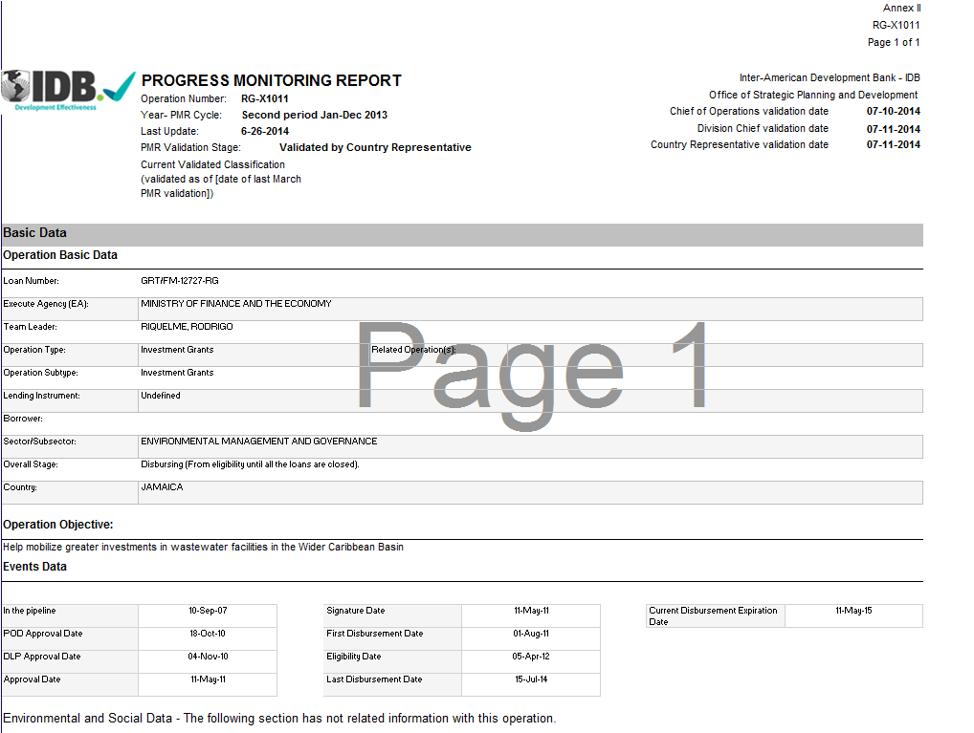
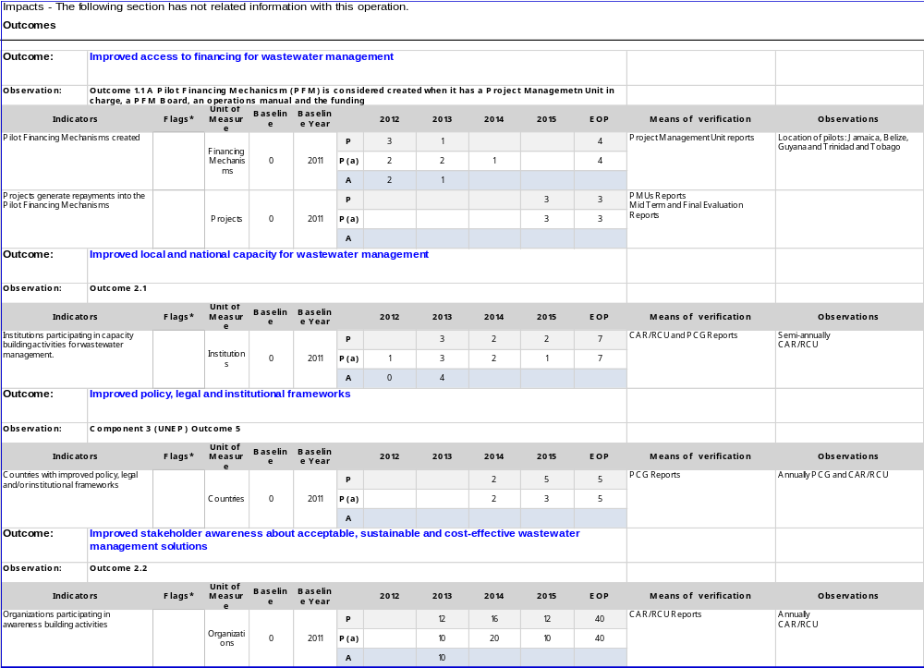

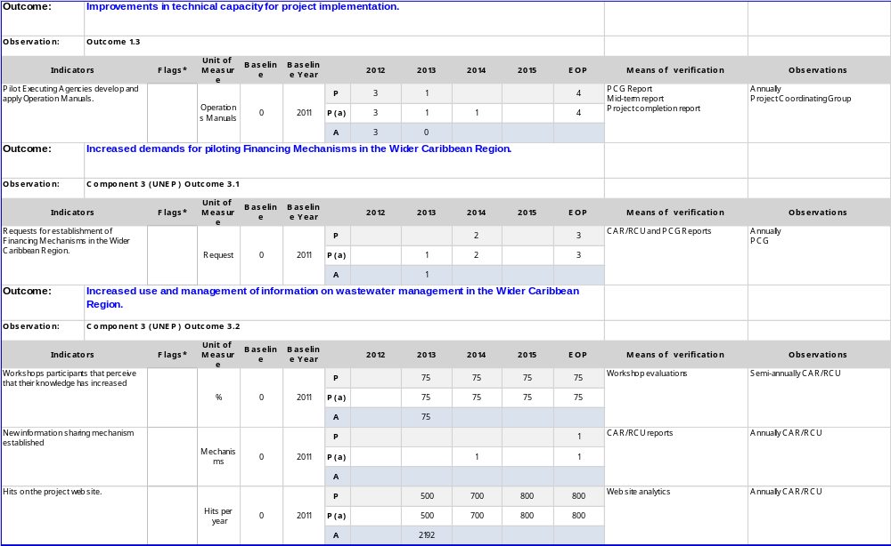

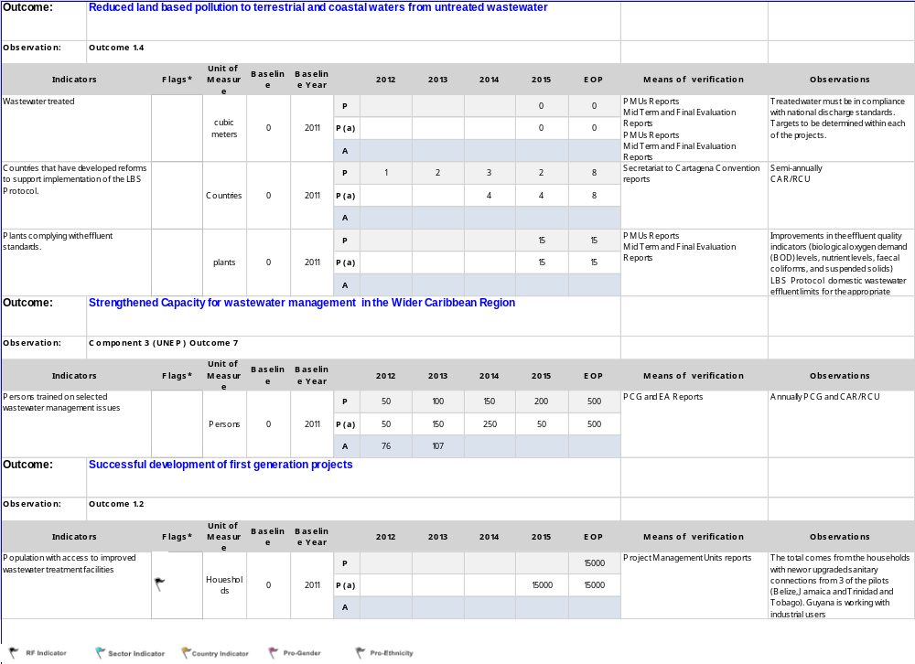
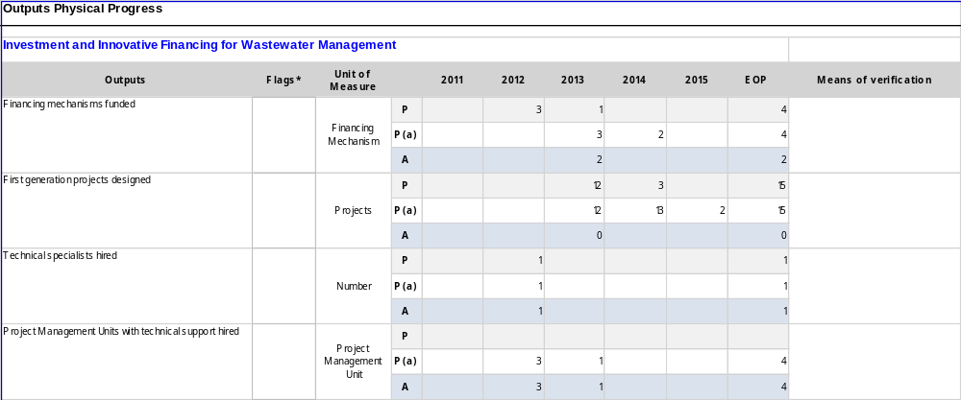

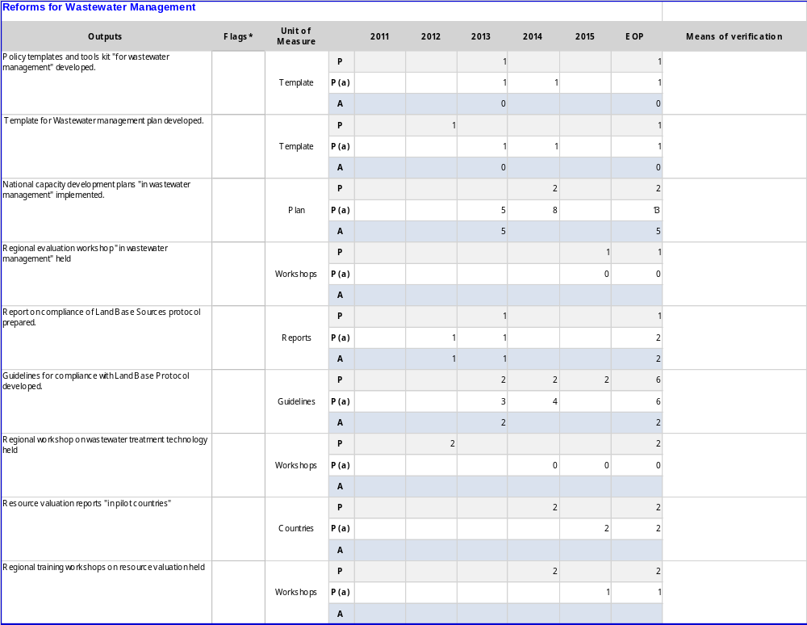
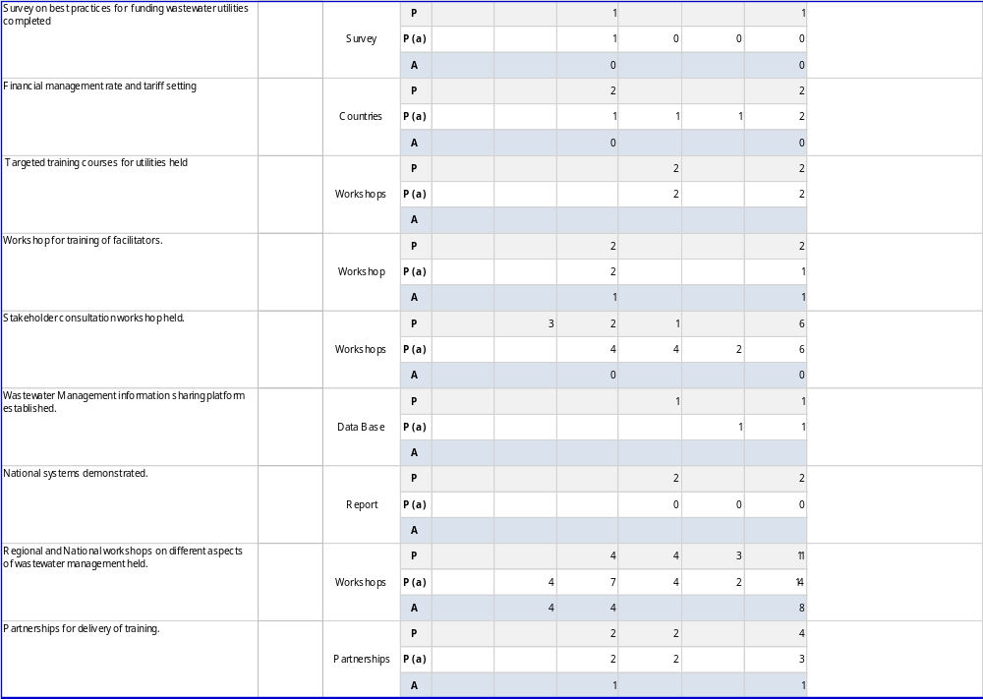

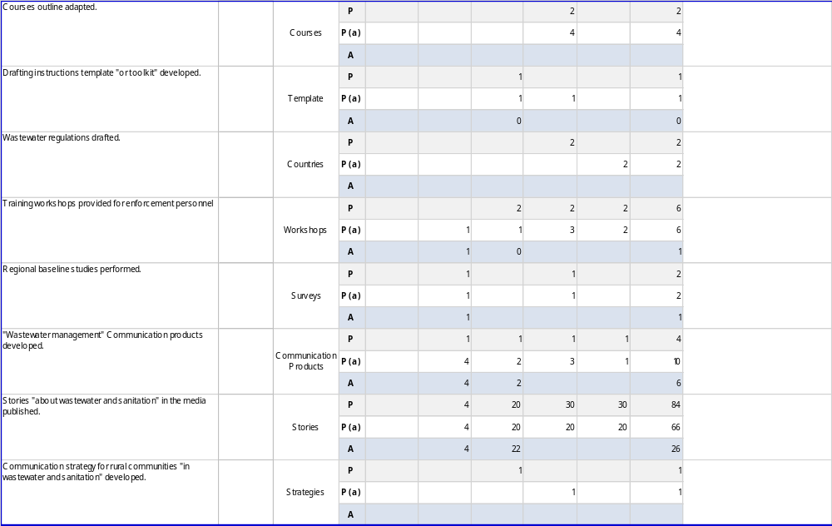

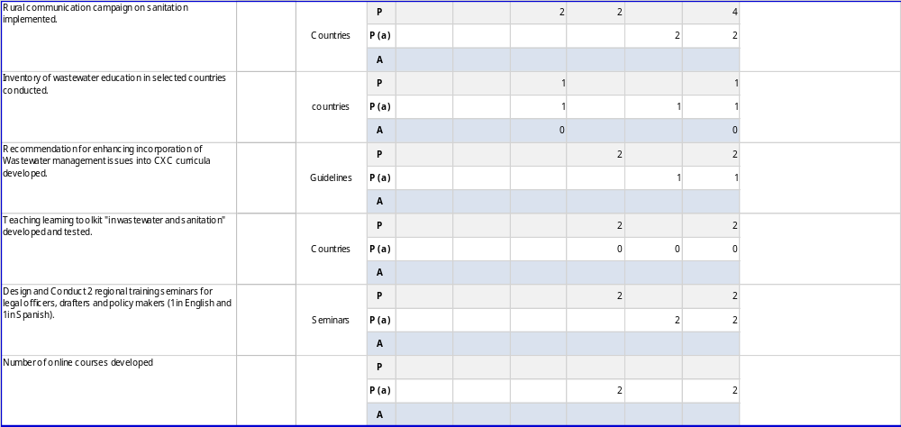

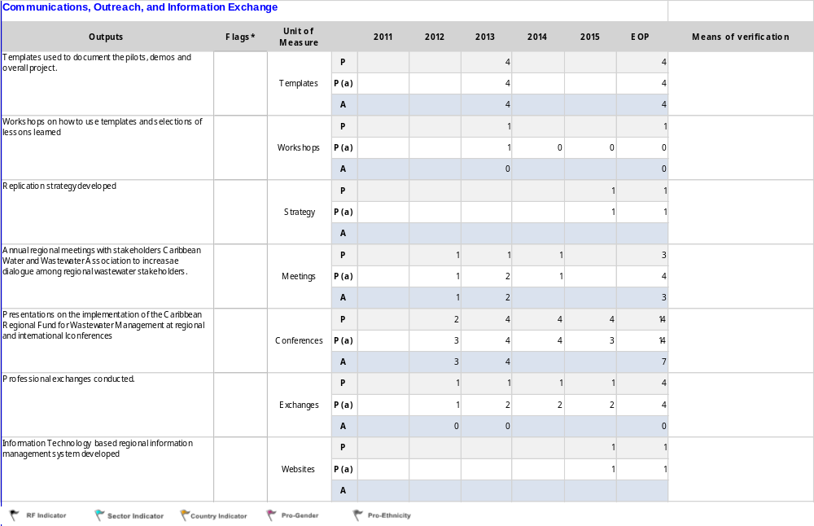
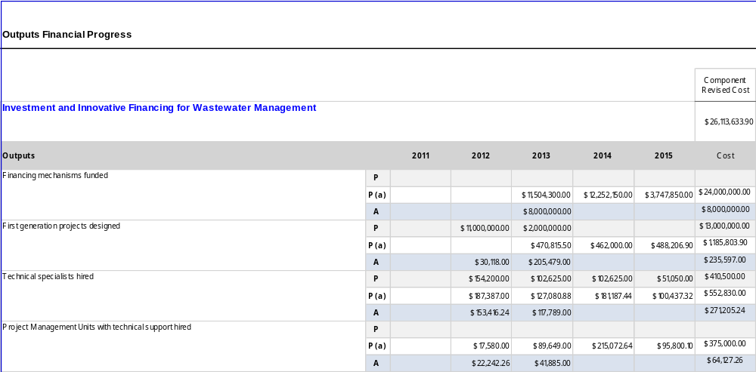

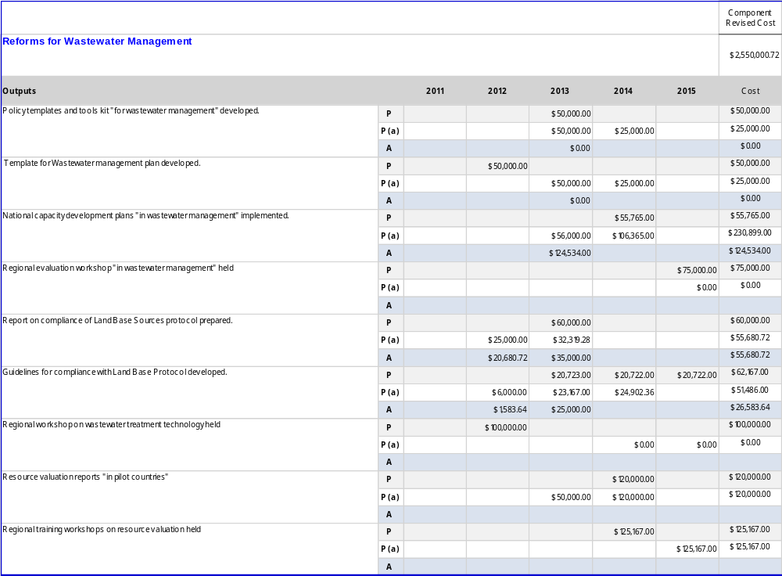
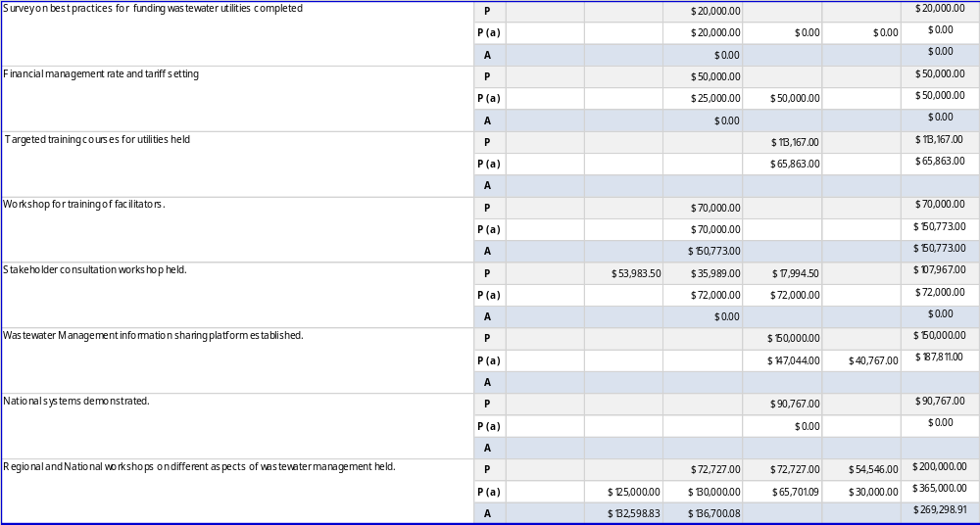

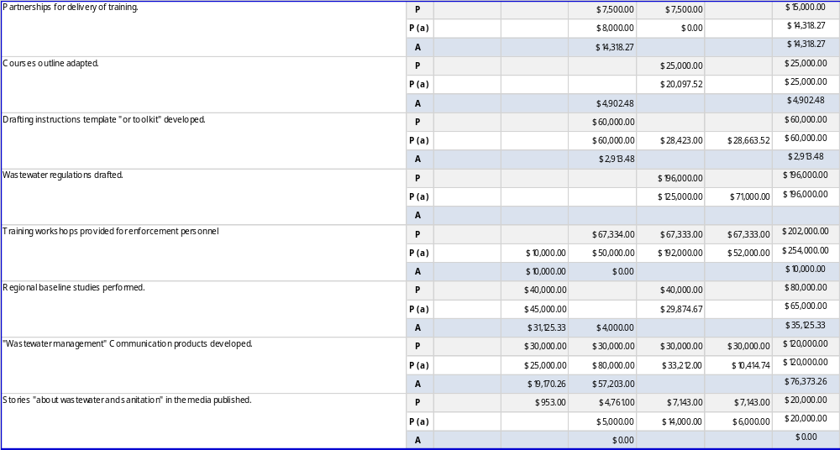

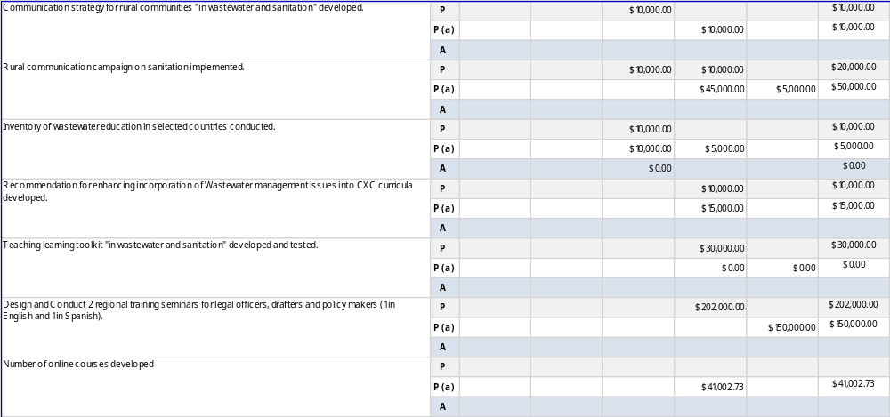

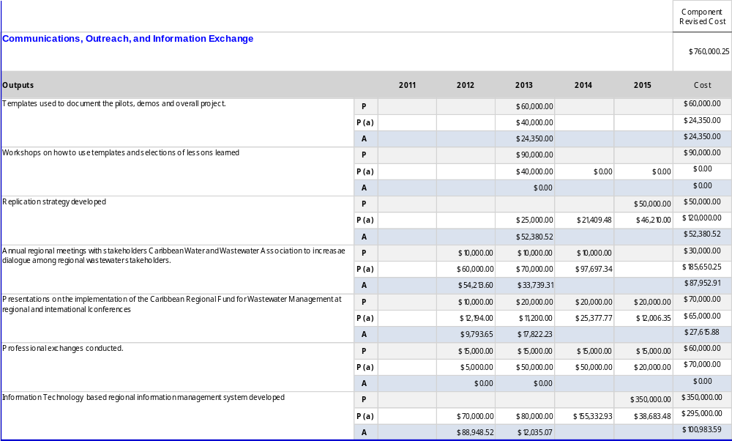

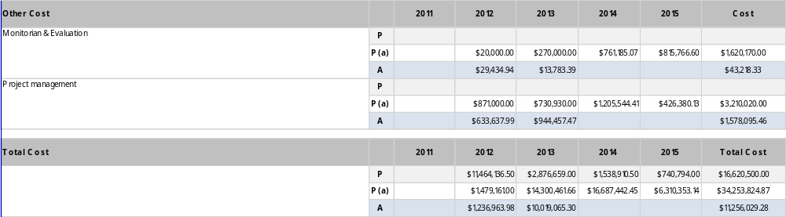

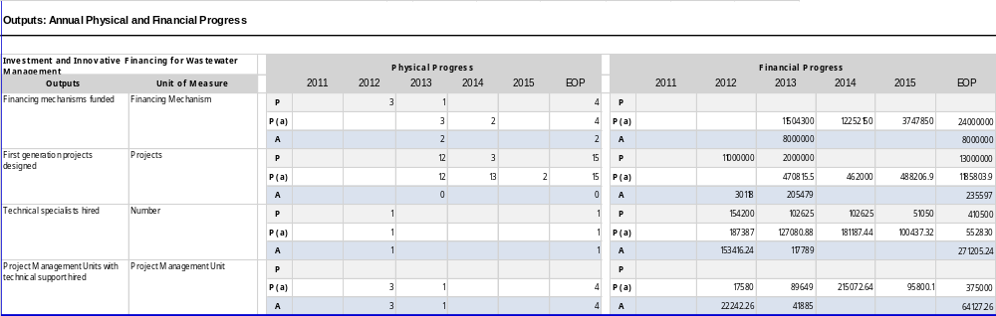

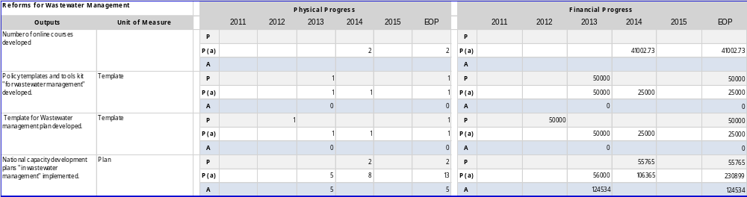

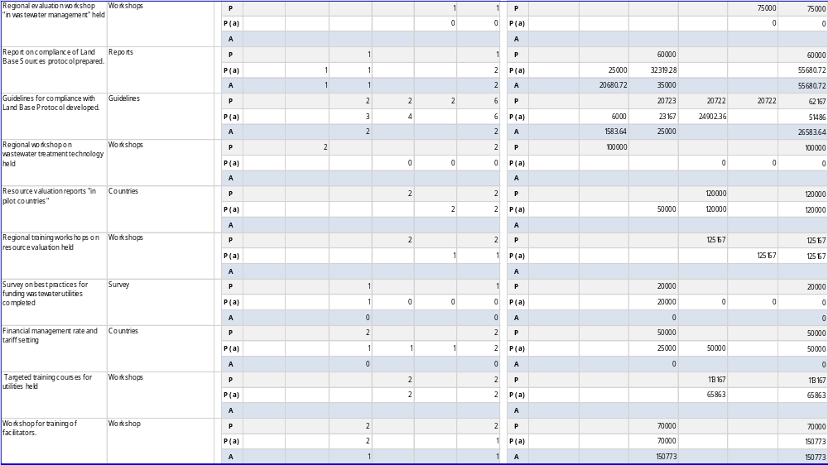

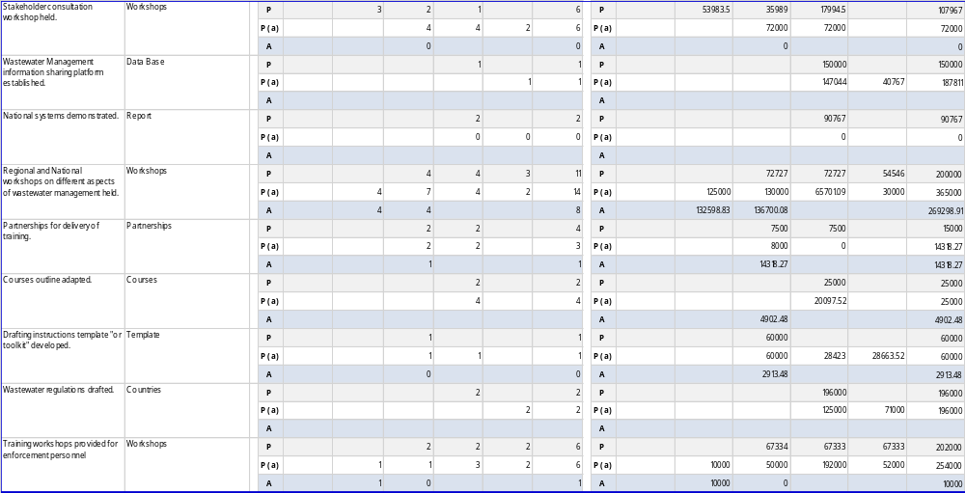

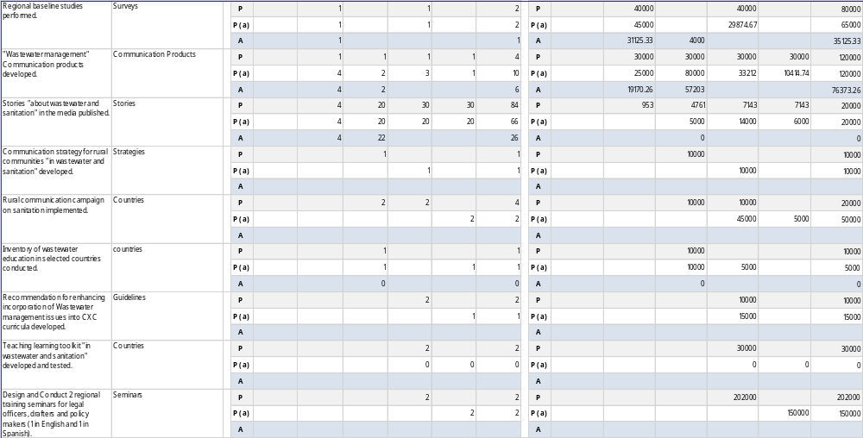

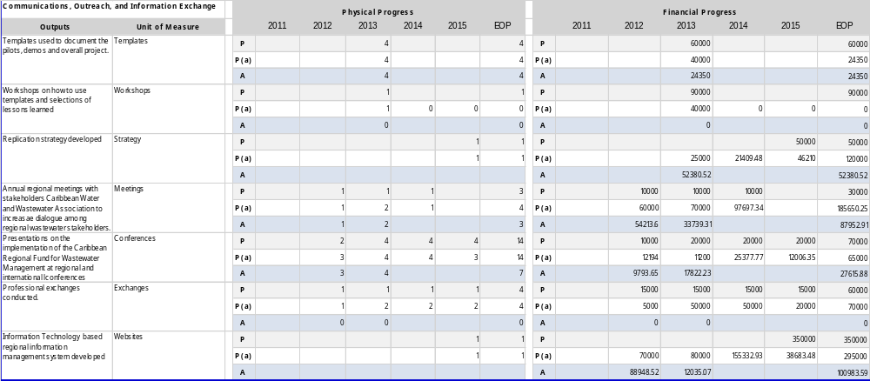

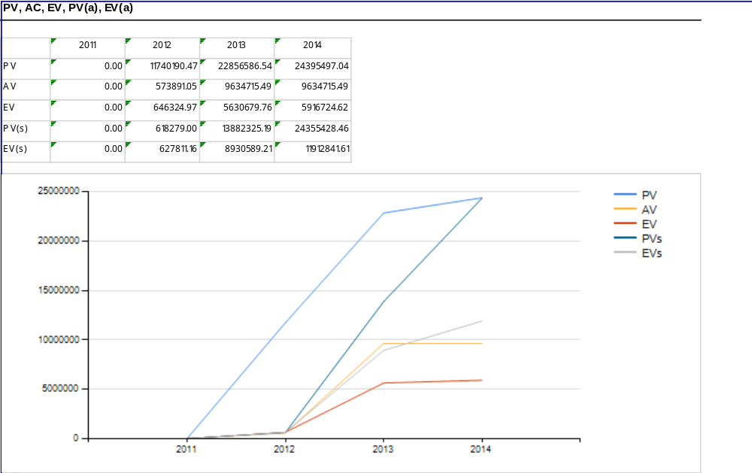

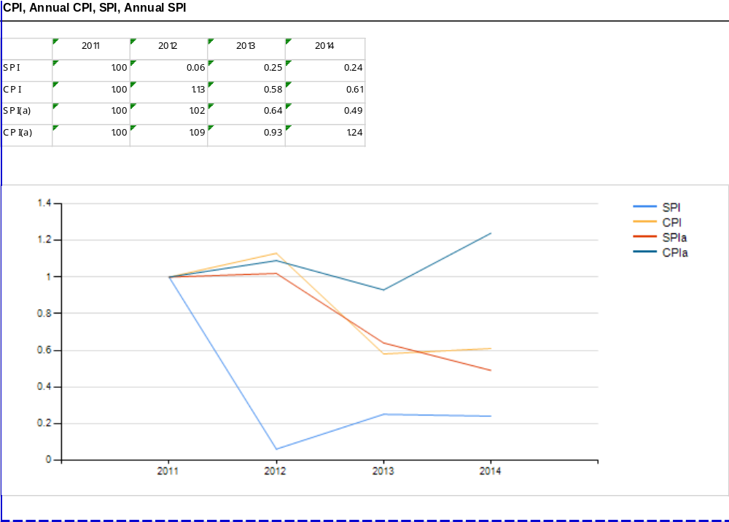

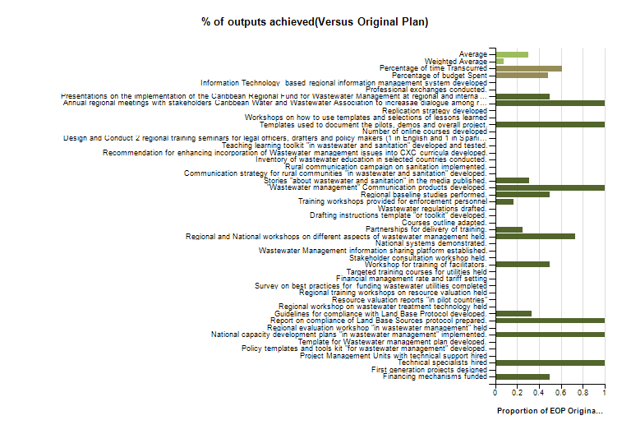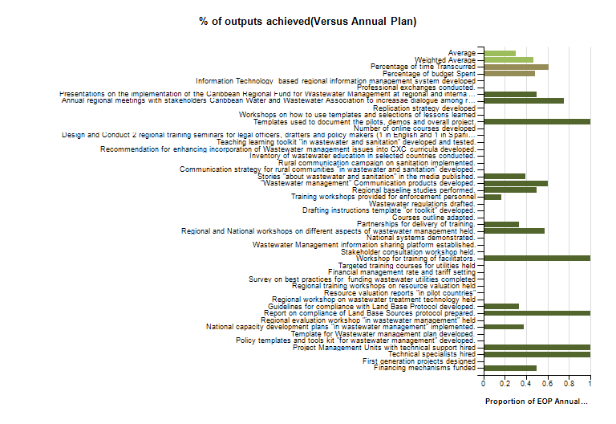

Section of Matrix | Name | Type of Change | Reasons | Date of change entered in the System | Date of changes agreed with executing agency
Output | Financing mechanisms funded | Modify Output | Error, this output has not changed in comparison with previous period, also there has been an error also while transferring the information from old to new system | 06-Jun-14
Output | First generation projects designed | Modify Output | includes Co-Financing from Belize of 58624.68 in 2013. Co-Financing was not budgeted for in project plan | 06-Jun-14
Output | Project Management Units with technical support hired | Modify Output | Error, this output has not changed. The transfer of information was correct but it did not take into account the approval of the change in a previous version of the PMR | 06-Jun-14
Output | Policy templates and tools kit "for wastewater management" developed. | Modify Output | Reduce budget from 50000 to 25000 Funds reallocated by Executing Agency United Nations Environmental Program/ Caribbean Regional Coordinating Unit in consultation with Project Coordination Group as part of the finalization of the work plan for 2014. | 06-Jun-14
Output | Template for Wastewater management plan developed. | Modify Output | Reduce budget from 50000 to 25000. Funds reallocated by Executing Agency United Nations Environmental Program/ Caribbean Regional Coordinating Unit in consultation with Project Coordination Group as part of the finalization of the work plan for 2014. | 06-Jun-14
Output | National capacity development plans "in wastewater management" implemented. | Modify Output | Targets increase from 2 to 13 Budget increases from 106000 to 230899 Target number was revised in 2013 to accommodate one small scale finance agreement for each participating country.Funds reallocated from Activities where there was under expenditure, given the increase in the target. | 06-Jun-14
Output | Regional evaluation workshop "in wastewater management" held | Modify Output | Removed during the revision of the Results Matrix at Mid Term Evaluation and approved by the Inter Agency Coordination Group and the Project Steering Committee. Funds reallocated to assist activities which are under budgeted. | 06-Jun-14
Output | Guidelines for compliance with Land Base Protocol developed. | Modify Output | Funds were over expended for output "Report on compliance of Land Base Sources protocol prepared" based on the initial budget. As this report forms a base for the preparation of the guidelines,funds for that output had to be collected from other related outputs. | 06-Jun-14
Output | Regional workshop on wastewater treatment technology held | Modify Output | Removed during the revision of the Results Matrix at Mid Term Evaluation and approved by the Inter Agency Coordination Group and the Project Steering Committee. Funds reallocated to assist activities which are under budgeted. | 06-Jun-14
Output | Regional training workshops on resource valuation held | Modify Output | Targets reduce from 2 to 1, Changed during the revision of the Results Matrix at Mid Term Evaluation and approved by the Inter Agency Coordination Group and the Project Steering Committee. Funds reallocated to assist activities which are under budgeted. | 06-Jun-14
Output | Cost recovery models tested | Modify Output | New output text changed to better reflect activity and to be more SPECIFIC-MEASURABLE-ACCURATE-REALISTIC AND TIME BOUND "SMART" | 06-Jun-14
Output | Stakeholder consultation workshop held. | Modify Output | Budget decreases from 108000 to 72000. Funds reallocated from this activity because Stakeholder Workshop would be undertaken in National Capacity Plan II.1.1.3. | 06-Jun-14
Output | National systems demonstrated. | Modify Output | Removed during the revision of the Results Matrix and approved by the Inter Agency Coordination Group and the Project Steering Committee. Funds reallocated to assist activities which are under budgeted. | 06-Jun-14
Output | Regional and National workshops on different aspects of wastewater management held. | Modify Output | Targets increases from 11 to 14 Budget increase from 305000 to 365000 Targets number was changed during earlier versions and during the development of the 2014 work plan, additional funds were allocated from an area of under expenditure to execute activities i.e. II.1.1.1 and II.1.1.2 | 06-Jun-14
Output | Courses outline adapted. | Modify Output | argets increases from 2 to 4 Changed during the revision of the Results Matrix at Mid Term Evaluation and approved by the Inter Agency Coordination Group and the Project Steering Committee. | 06-Jun-14
Output | Drafting instructions template "or toolkit" developed. | Modify Output | his is an error, there is not modification in the ouput | 06-Jun-14
Output | Training workshops provided for enforcement personnel | Modify Output | Budget increase from 202000 to 254000 Changed during the revision of the Results Matrix at Mid Term Evaluation and approved by the Inter Agency Coordination Group and the Project Steering Committee. | 06-Jun-14
Output | "Wastewater management" Communication products developed. | Modify Output | Target increases from 4 to 10 Changed during the revision of the Results Matrix at Mid Term Evaluation and approved by the Inter Agency Coordination Group and the Project Steering Committee. | 06-Jun-14
Output | Rural communication campaign on sanitation implemented. | Modify Output | Budget increases from 20000 to 50000 Changed during the revision of the Results Matrix at Mid Term Evaluation and approved by the Inter Agency Coordination Group and the Project Steering Committee. | 06-Jun-14
Output | Inventory of wastewater education in selected countries conducted. | Modify Output | Budget decreases from 10000 to 5000 Changed during the revision of the Results Matrix at Mid Term Evaluation and approved by the Inter Agency Coordination Group and the Project Steering Committee. | 06-Jun-14
Output | Guidelines for enhancing incorporation of wastewater management issues into curricula developed. | Modify Output | Target decreases from 2 to 1 Changed during the revision of the Results Matrix at Mid Term Evaluation and approved by the Inter Agency Coordination Group and the Project Steering Committee. | 06-Jun-14
Output | Teaching learning toolkit "in wastewater and sanitation" developed and tested. | Modify Output | Removed during the revision of the Results Matrix at Mid Term Evaluation and approved by the Inter Agency Coordination Group and the Project Steering Committee. Funds reallocated to assist activities which are under budgeted. | 06-Jun-14
Output | Annual regional meetings with stakeholders Caribbean Water and Wastewater Association to increasae dialogue among regional wastewater stakeholders. | Modify Output | Target increases from 3 to 4 Budget increases from 150000 to 185650 Number of meetings requiring project to be represented has increased. | 06-Jun-14
Output | Presentations on the implementation of the Caribbean Regional Fund for Wastewater Management at regional and international lconferences | Modify Output | total new budget 65000 in stead of 70000. It has been estimated that the total cost will be reduced in 5000 USD | 06-Jun-14
Output | Professional exchanges conducted. | Modify Output | In Dialogue with United Nation Environmental Program Revision in the total cost: Has been estimated that the total cost will increase in 10000 USD from 60000 to 70000 USD. | 06-Jun-14
Output | Financial management rate and tariff setting | Modify Output | New output text changed to better reflect activity and to be more SPECIFIC-MEASURABLE-ACCURATE-REALISTIC AND TIME BOUND "SMART" | 06-Jun-14
Output | Targeted training courses for utilities held | Modify Output | New output text changed to better reflect activity and to be more SPECIFIC-MEASURABLE-ACCURATE-REALISTIC AND TIME BOUND "SMART" | 06-Jun-14
Output | Wastewater Management information sharing platform established. | Modify Output | New output text changed to better reflect activity and to be more SPECIFIC-MEASURABLE-ACCURATE-REALISTIC AND TIME BOUND "SMART" | 06-Jun-14
Output | Wastewater regulations drafted. | Modify Output | New output text changed to better reflect activity and to be more SPECIFIC-MEASURABLE-ACCURATE-REALISTIC AND TIME BOUND "SMART".Approved by the Inter Agency Coordination Group and the Project Steering Committee | 06-Jun-14
Output | Recommendation for enhancing incorporation of Wastewater management issues into CXC curricula developed. | Modify Output | New output text changed to better reflect activity and to be more SPECIFIC-MEASURABLE-ACCURATE-REALISTIC AND TIME BOUND "SMART" | 06-Jun-14
Outcome | Institutions participating in capacity building activities for wastewater management. | Modify Outcome Indicator | There was in error in previous versions of the PMR which had a outcome target of 8. This PMR has the correct outcome target of 7. | 07-Jun-14
Output | Number of online courses developed | Create Output | During the Mid Term Evaluation the indicators were revised to reflect the rethinking in the program that is to introduce more online training and to provide better descriptor for the activities | 07-Jun-14

Changes to the Matrix
Name | Type of change | Reasons | Effects or implication (negative or positive) of the changes | Actions or decisions recommended to replicate or avoid
Financing mechanisms funded | Output | Error, this output has not changed in comparison with previous period, also there has been an error also while transferring the information from old to new system
First generation projects designed | Output | includes Co-Financing from Belize of 58624.68 in 2013. Co-Financing was not budgeted for in project plan
Project Management Units with technical support hired | Output | Error, this output has not changed. The transfer of information was correct but it did not take into account the approval of the change in a previous version of the PMR
Policy templates and tools kit "for wastewater management" developed. | Output | Reduce budget from 50000 to 25000 Funds reallocated by Executing Agency United Nations Environmental Program/ Caribbean Regional Coordinating Unit in consultation with Project Coordination Group as part of the finalization of the work plan for 2014.
Template for Wastewater management plan developed. | Output | Reduce budget from 50000 to 25000. Funds reallocated by Executing Agency United Nations Environmental Program/ Caribbean Regional Coordinating Unit in consultation with Project Coordination Group as part of the finalization of the work plan for 2014.
National capacity development plans "in wastewater management" implemented. | Output | Targets increase from 2 to 13 Budget increases from 106000 to 230899 Target number was revised in 2013 to accommodate one small scale finance agreement for each participating country.Funds reallocated from Activities where there was under expenditure, given the increase in the target.
Regional evaluation workshop "in wastewater management" held | Output | Removed during the revision of the Results Matrix at Mid Term Evaluation and approved by the Inter Agency Coordination Group and the Project Steering Committee. Funds reallocated to assist activities which are under budgeted.
Guidelines for compliance with Land Base Protocol developed. | Output | Funds were over expended for output "Report on compliance of Land Base Sources protocol prepared" based on the initial budget. As this report forms a base for the preparation of the guidelines,funds for that output had to be collected from other related outputs. |  | No recommendations, the amount is almost the same
Regional workshop on wastewater treatment technology held | Output | Removed during the revision of the Results Matrix at Mid Term Evaluation and approved by the Inter Agency Coordination Group and the Project Steering Committee. Funds reallocated to assist activities which are under budgeted.
Regional training workshops on resource valuation held | Output | Targets reduce from 2 to 1, Changed during the revision of the Results Matrix at Mid Term Evaluation and approved by the Inter Agency Coordination Group and the Project Steering Committee. Funds reallocated to assist activities which are under budgeted.
Cost recovery models tested | Output | New output text changed to better reflect activity and to be more SPECIFIC-MEASURABLE-ACCURATE-REALISTIC AND TIME BOUND "SMART"
Stakeholder consultation workshop held. | Output | Budget decreases from 108000 to 72000. Funds reallocated from this activity because Stakeholder Workshop would be undertaken in National Capacity Plan II.1.1.3.
National systems demonstrated. | Output | Removed during the revision of the Results Matrix and approved by the Inter Agency Coordination Group and the Project Steering Committee. Funds reallocated to assist activities which are under budgeted.
Regional and National workshops on different aspects of wastewater management held. | Output | Targets increases from 11 to 14 Budget increase from 305000 to 365000 Targets number was changed during earlier versions and during the development of the 2014 work plan, additional funds were allocated from an area of under expenditure to execute activities i.e. II.1.1.1 and II.1.1.2
Courses outline adapted. | Output | argets increases from 2 to 4 Changed during the revision of the Results Matrix at Mid Term Evaluation and approved by the Inter Agency Coordination Group and the Project Steering Committee.
Drafting instructions template "or toolkit" developed. | Output | his is an error, there is not modification in the ouput
Training workshops provided for enforcement personnel | Output | Budget increase from 202000 to 254000 Changed during the revision of the Results Matrix at Mid Term Evaluation and approved by the Inter Agency Coordination Group and the Project Steering Committee.
"Wastewater management" Communication products developed. | Output | Target increases from 4 to 10 Changed during the revision of the Results Matrix at Mid Term Evaluation and approved by the Inter Agency Coordination Group and the Project Steering Committee.
Rural communication campaign on sanitation implemented. | Output | Budget increases from 20000 to 50000 Changed during the revision of the Results Matrix at Mid Term Evaluation and approved by the Inter Agency Coordination Group and the Project Steering Committee.
Inventory of wastewater education in selected countries conducted. | Output | Budget decreases from 10000 to 5000 Changed during the revision of the Results Matrix at Mid Term Evaluation and approved by the Inter Agency Coordination Group and the Project Steering Committee.
Guidelines for enhancing incorporation of wastewater management issues into curricula developed. | Output | Target decreases from 2 to 1 Changed during the revision of the Results Matrix at Mid Term Evaluation and approved by the Inter Agency Coordination Group and the Project Steering Committee.
Teaching learning toolkit "in wastewater and sanitation" developed and tested. | Output | Removed during the revision of the Results Matrix at Mid Term Evaluation and approved by the Inter Agency Coordination Group and the Project Steering Committee. Funds reallocated to assist activities which are under budgeted.
Annual regional meetings with stakeholders Caribbean Water and Wastewater Association to increasae dialogue among regional wastewater stakeholders. | Output | Target increases from 3 to 4 Budget increases from 150000 to 185650 Number of meetings requiring project to be represented has increased.
Presentations on the implementation of the Caribbean Regional Fund for Wastewater Management at regional and international lconferences | Output | total new budget 65000 in stead of 70000. It has been estimated that the total cost will be reduced in 5000 USD
Professional exchanges conducted. | Output | In Dialogue with United Nation Environmental Program Revision in the total cost: Has been estimated that the total cost will increase in 10000 USD from 60000 to 70000 USD.
Financial management rate and tariff setting | Output | New output text changed to better reflect activity and to be more SPECIFIC-MEASURABLE-ACCURATE-REALISTIC AND TIME BOUND "SMART"
Targeted training courses for utilities held | Output | New output text changed to better reflect activity and to be more SPECIFIC-MEASURABLE-ACCURATE-REALISTIC AND TIME BOUND "SMART"
Wastewater Management information sharing platform established. | Output | New output text changed to better reflect activity and to be more SPECIFIC-MEASURABLE-ACCURATE-REALISTIC AND TIME BOUND "SMART"
Wastewater regulations drafted. | Output | New output text changed to better reflect activity and to be more SPECIFIC-MEASURABLE-ACCURATE-REALISTIC AND TIME BOUND "SMART".Approved by the Inter Agency Coordination Group and the Project Steering Committee
Recommendation for enhancing incorporation of Wastewater management issues into CXC curricula developed. | Output | New output text changed to better reflect activity and to be more SPECIFIC-MEASURABLE-ACCURATE-REALISTIC AND TIME BOUND "SMART"
Institutions participating in capacity building activities for wastewater management. | Outcome | There was in error in previous versions of the PMR which had a outcome target of 8. This PMR has the correct outcome target of 7.
Number of online courses developed | Output | During the Mid Term Evaluation the indicators were revised to reflect the rethinking in the program that is to introduce more online training and to provide better descriptor for the activities

Delays in achievement of annual plans for Outputs and Outcomes
Type of Delay | Name | is the issue solved? | Last update
Output delay | Policy templates and tools kit "for wastewater management" developed. | Yes | 6-25-2014
Output delay | Template for Wastewater management plan developed. | Yes | 6-25-2014
Output delay | Guidelines for compliance with Land Base Protocol developed. | Yes | 6-25-2014
Output delay | Financial management rate and tariff setting | Yes | 6-25-2014
Output delay | Stakeholder consultation workshop held. | Yes | 6-25-2014
Output delay | Regional and National workshops on different aspects of wastewater management held. | Yes | 6-25-2014
Output delay | Partnerships for delivery of training. | Yes | 6-25-2014
Output delay | Drafting instructions template "or toolkit" developed. | Yes | 6-25-2014
Output delay | Training workshops provided for enforcement personnel | Yes | 6-25-2014
Output delay | Inventory of wastewater education in selected countries conducted. | Yes | 6-25-2014
Output delay | Workshops on how to use templates and selections of lessons learned | Yes | 6-25-2014
Output delay | Professional exchanges conducted. | Yes | 6-25-2014
Output delay | National capacity development plans "in wastewater management" implemented. | Yes | 6-25-2014
Output delay | Resource valuation reports "in pilot countries" | Yes | 6-25-2014
Output delay | Survey on best practices for funding wastewater utilities completed | Yes | 6-25-2014
Output delay | Courses outline adapted. | Yes | 6-25-2014
Outcome delay | Pilot Financing Mechanisms created | Yes | 6-25-2014
Outcome delay | Pilot Executing Agencies develop and apply Operation Manuals. | Yes | 6-25-2014
Outcome delay | Persons trained on selected wastewater management issues | Yes | 6-25-2014
Output delay | Financing mechanisms funded | Yes | 6-25-2014
Output delay | First generation projects designed | Yes | 6-25-2014
Output delay | Workshop for training of facilitators. | Yes | 6-25-2014

Annex 5- Mid Term Evaluation Report

Although using the UNEP format, this report has been prepared and cleared by the PCG and both IAs, and will be submitted by both agencies to the GEF Sec.
Fields with an * sign (in yellow) should be filled by the Fund Management Officer
Only if different from first disbursement date, e.g., in cases were a long time elapsed between first disbursement and recruitment of project manager.
If there was a “Completion Revision” please use the date of the revision.
Information to be provided by Executing Agency/Project Manager
Projects which completed mid-term reviews/evaluations or terminal evaluations during FY12 should attach the completed co-financing table as per GEF format. See Annex 1
See above note on co-financing
As in project document
Please add additional lines to keep prior year implementation status (if any)
Please add additional lines to keep prior year implementation status (if any)
Please add additional lines to keep prior year implementation status (if any)
For Full Size Projects this information is found in the front page of the project Executive Summary; for Medium-Sized Projects the information appears in the MSP brief cover page.
Or immediate project objective
Projects that did not include these in original design are encouraged to the extent possible to retrofit specific targets.
For joint projects and where applicable ratings should also be discussed with the Task Manager of co-implementing agency.
Add rows if your project has more than 3 key indicators per objective or outcome.
Depending on selected indicator, quantitative or qualitative baseline levels and targets could be used (see Glossary included as Annex 1).
Many projects did not identify Mid-term targets at the design stage therefore this column should only be filled if relevant.
Use GEF Secretariat required six-point scale system: Highly Satisfactory (HS), Satisfactory (S), Marginally Satisfactory (MS), Marginally Unsatisfactory (MU), Unsatisfactory (U), and Highly Unsatisfactory (HU). See Annex 2 which contains GEF definitions.
Add rows if your project has more than 4 objective-level indicators. Same applies for the number of outcome-level indicators.
Final target for each project to be determined based on local standards, LBS protocol and other environmental factors.
Outputs and activities as described in the project logframe or in any updated project revision.
As per latest work plan (latest project revision)
Variance refers to the difference between the expected and actual progress at the time of reporting.
To be provided by the UNEP Task Manager
To be provided by the UNEP Task Manager
Use GEF Secretariat required six-point scale system: Highly Satisfactory (HS), Satisfactory (S), Marginally Satisfactory (MS), Marginally Unsatisfactory (MU), Unsatisfactory (U), and Highly Unsatisfactory (HU)
UNEP Fund Management Officer should also be consulted as appropriate.
Incorporated in 2013 report
Incorporated in 2014 report
Incorporated in 2013 report
Incorporated in 2014 report
Incorporated in 2013 report
Incorporated in 2014 report
Incorporated in 2013
Incorporated in 2013
Incorporated in 2013
Incorporated in 2013
Incorporated in 2014 report
Incorporated in 2013 report
Incorporated in 2014 report
Incorporated in 2013
Incorporated in 2014 report
Only for Substantial to High risk.
MTE will take place between August to November 2013
Do not include routine project reporting. Examples of M&E activities include stakeholder surveys, field surveys, steering committee meetings to assess project progress, peer review of documentation to ensure quality, etc.
Assumptions refer to elements of the “theory of change” or “intervention logic” (i.e, the problem is a result of A, therefore, if we change B, this will lead to C) and not to pre-conditions for project implementation. It is a common mistake to include statements such as “political will” as an assumption. This is rather a necessary condition to implement the project.

